* **Milestone 1: Set up your account**

**Activity 1: Sign up for a Zoho Books account and Login**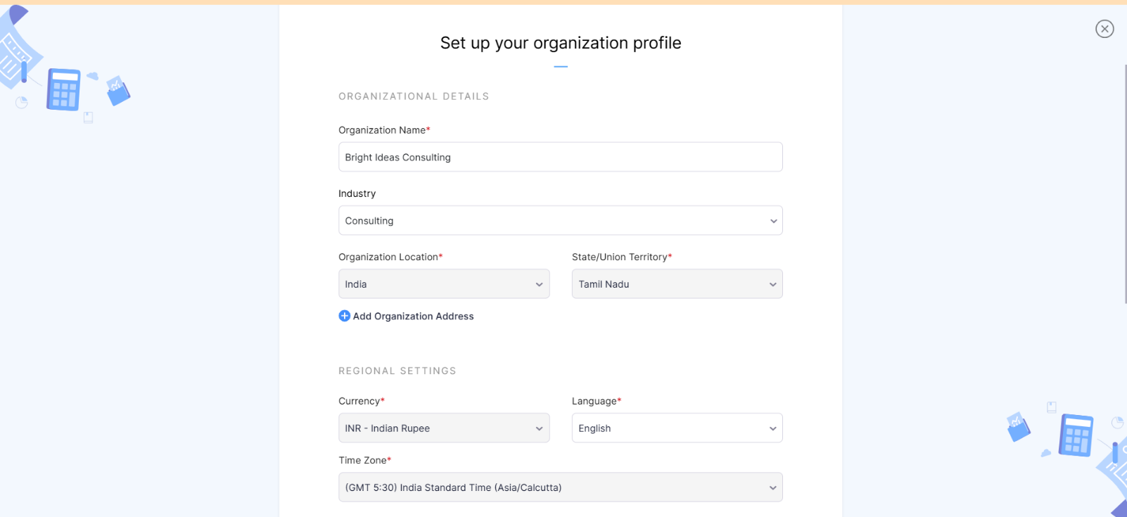

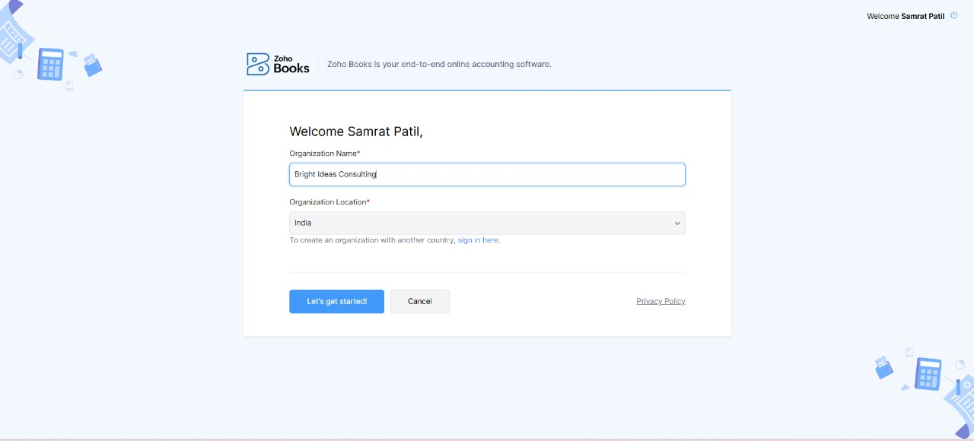

We create an organizational profile by adding the organization name “Bright Ideas Consulting” and then set up an organizational profile with appropriate information.

**Activity 2: Introduction**

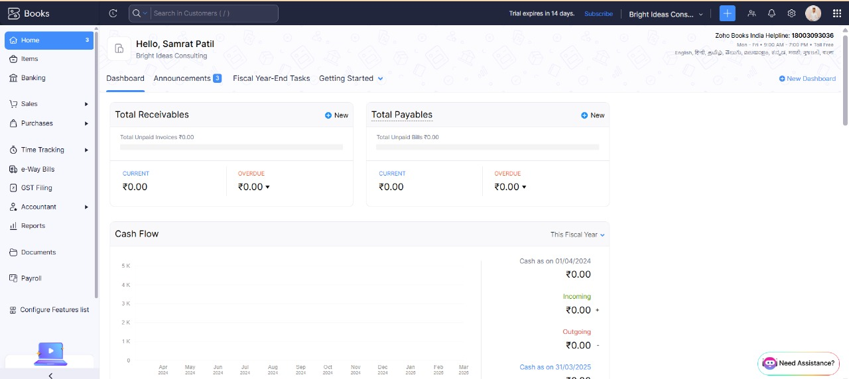

In this activity, we familiarised ourselves with all the tabs under Zoho books.

**Activity 3: let's get started**

Let’s Assume Bright Ideas Consulting is offering the below list of various services:

1. Management Consulting

2. Financial Consulting

3. Human Resources (HR) Consulting

4. Legal Consulting

The selling Price for all the above services is say Rs.1000/- per Consulting Hour. Output GST @ 18% is applicable for all the above services.

* **Milestone 2: Service Creation:**

**Activity 1: Creation**

1. Management Consulting

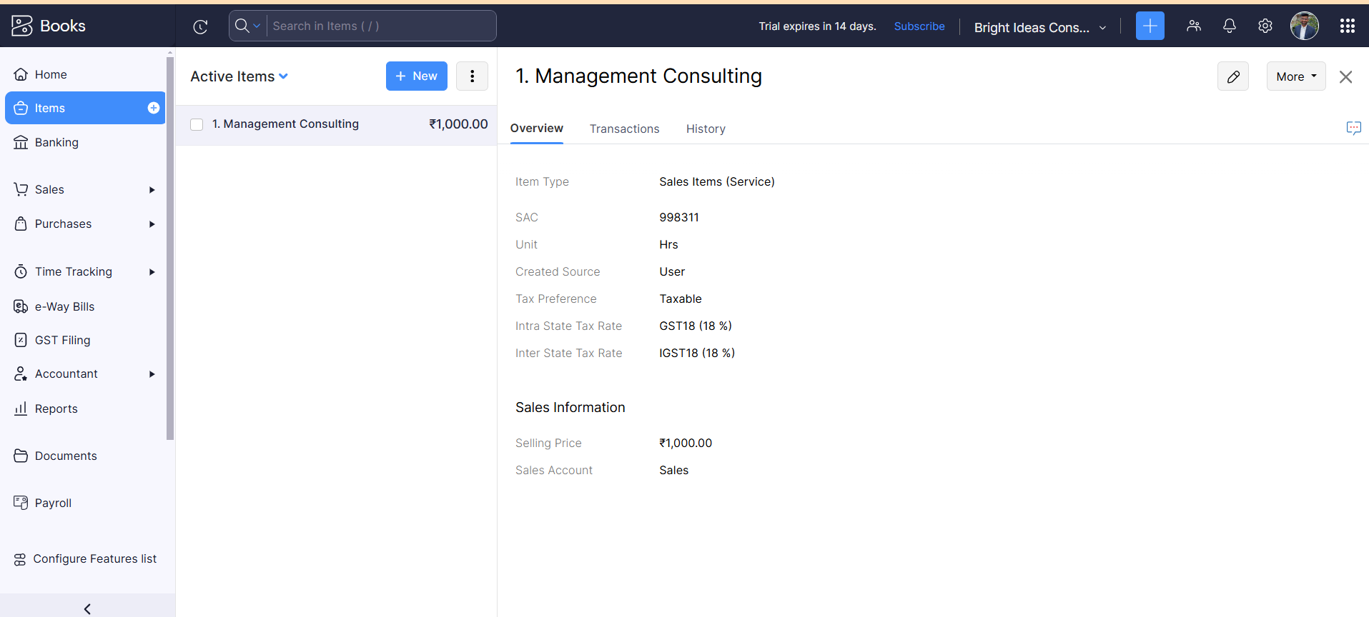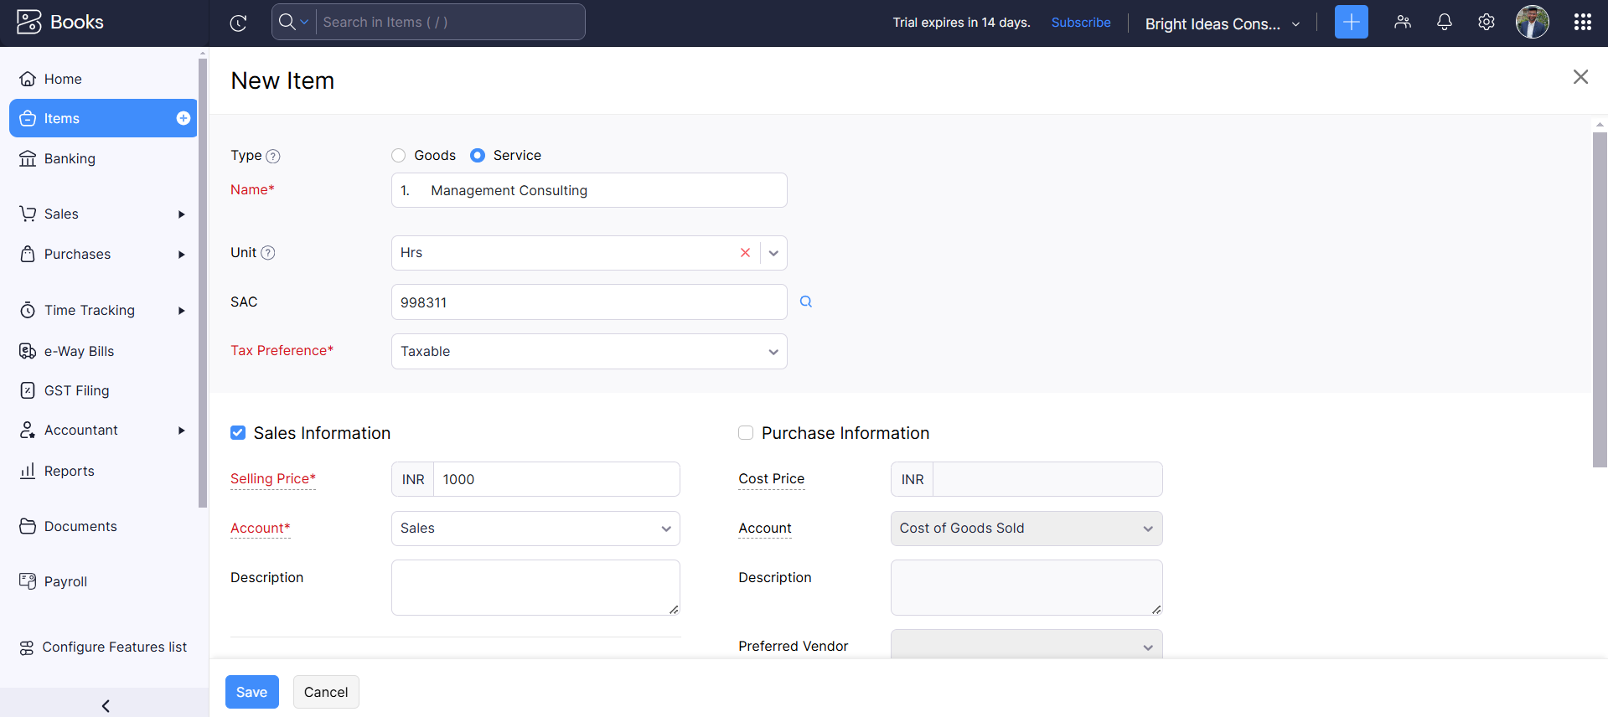

Here we create our first item/service creation which is management consulting. By going to **“Items”** from the Navigation Panel and clicking on **“+ New”** Button and give the respective fields such as

* Item Name
* Units (eg. Hrs)
* SAC Code of the Item (Eg: 998311)
* Sale Price
* Tax Rate

After providing all the required details click on save.

1. Financial Consulting:

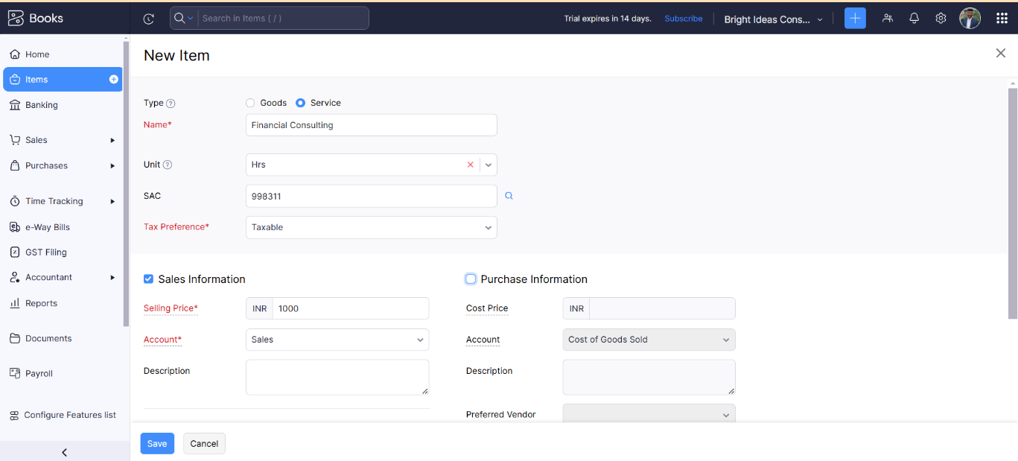

1. 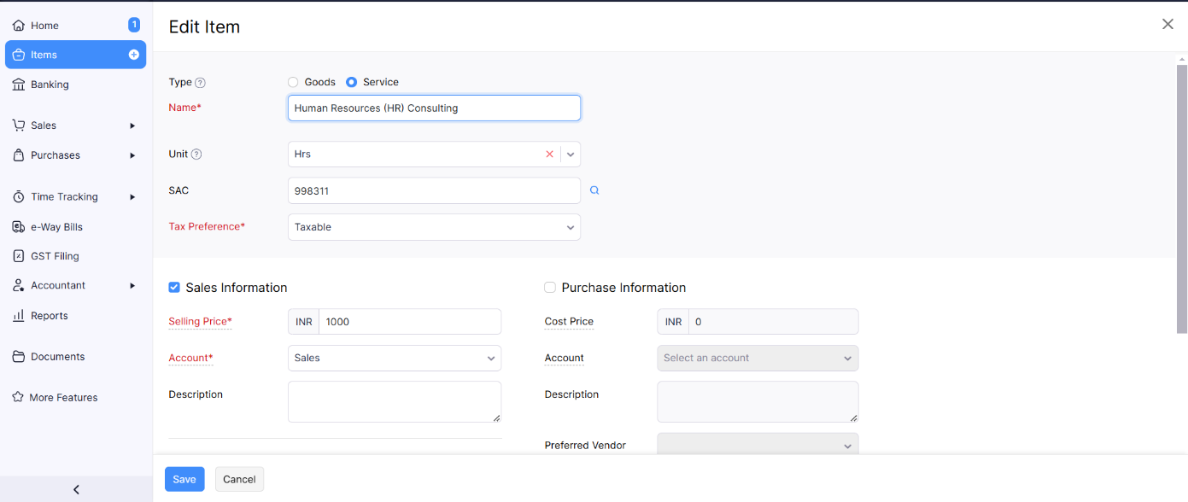Human Resources (HR) Consulting
2. Legal Consulting;

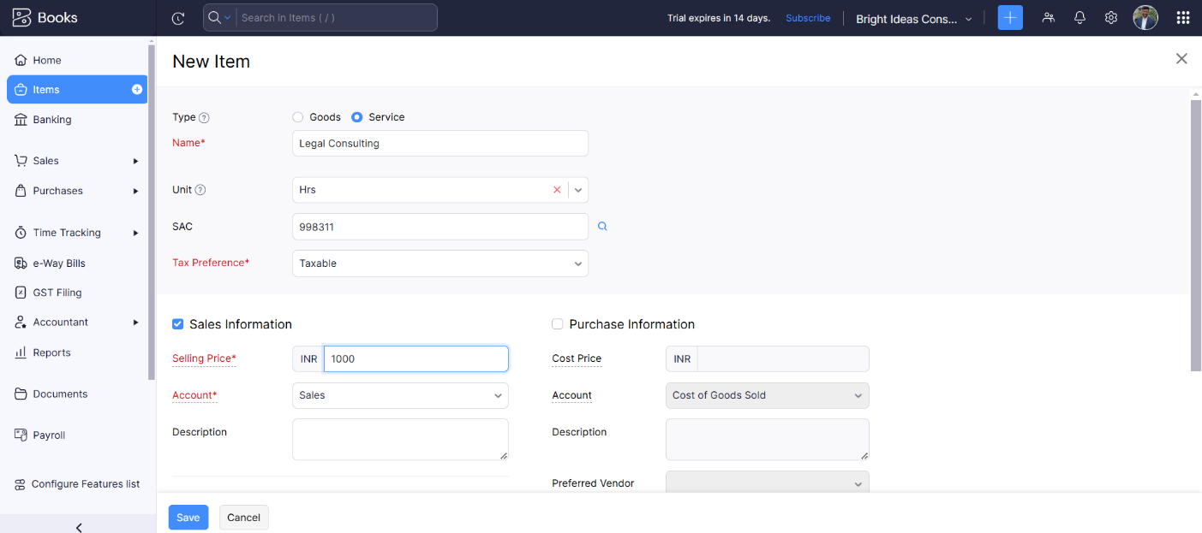

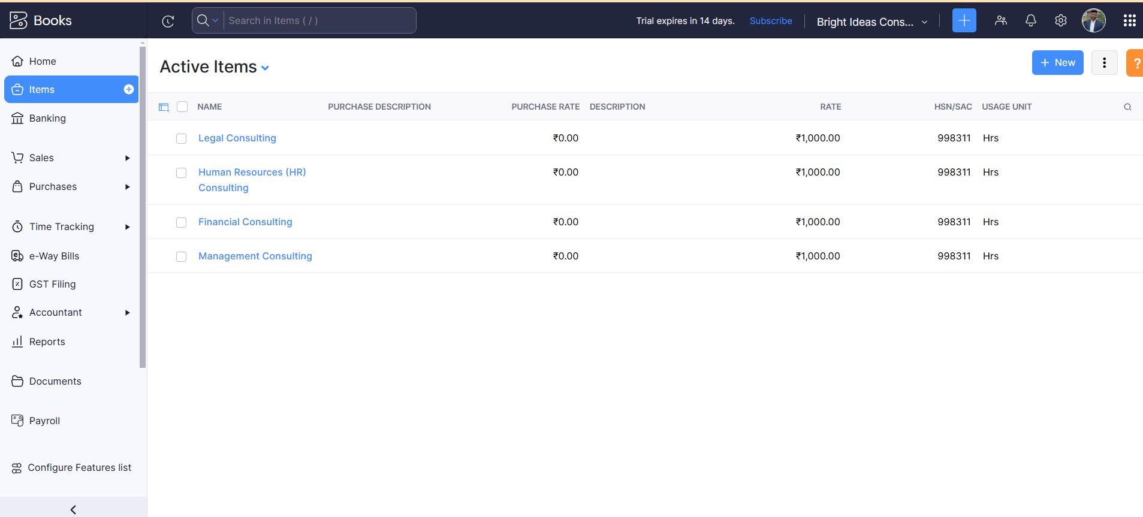**Activity 2: Review of Items after Addition**

Here we successfully added all the items that are:

1. Management Consulting

2. Financial Consulting

3. Human Resources (HR) Consulting

4. Legal Consulting

* **Milestone 3: Vendors**

**Activity 1: Vendor Creation**

1. **Randstad Technologies**

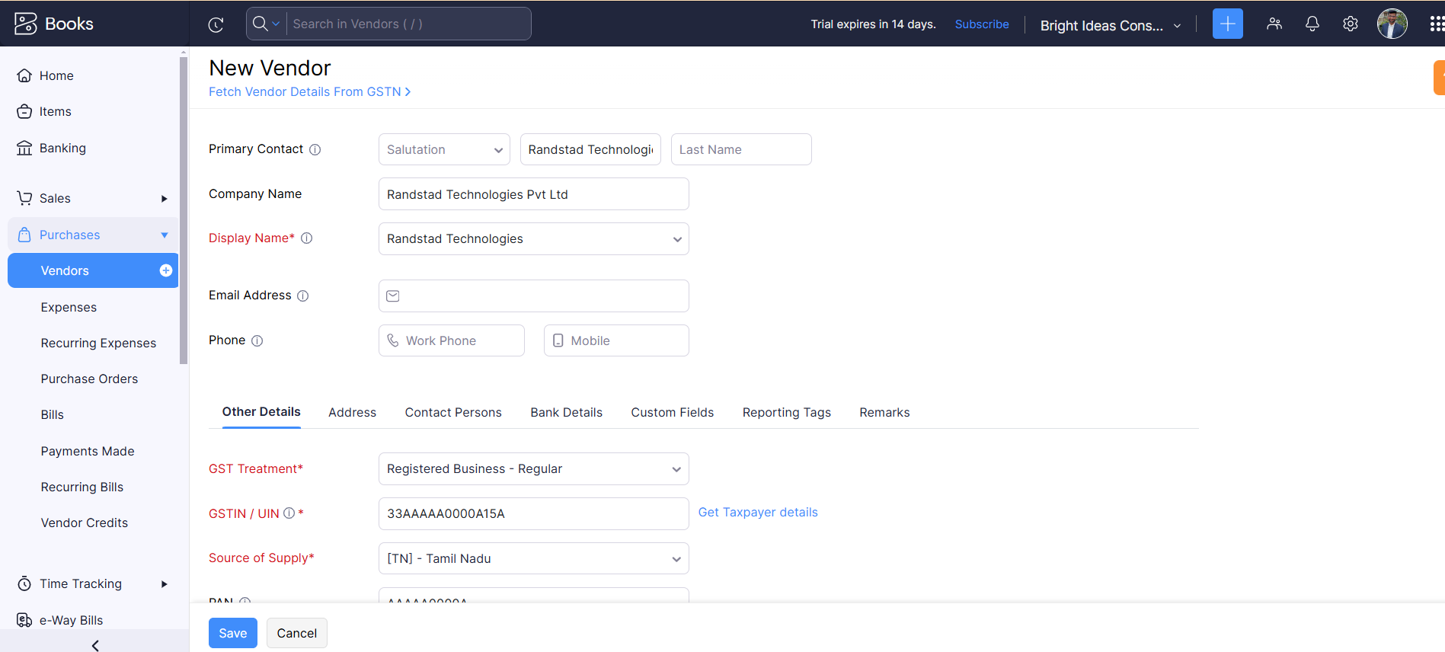

Here we successfully created one Vendor in books from the Navigation Panel while going to Purchases>Vendors>Create New Vendors and add the respective fields>Click on save.

1. 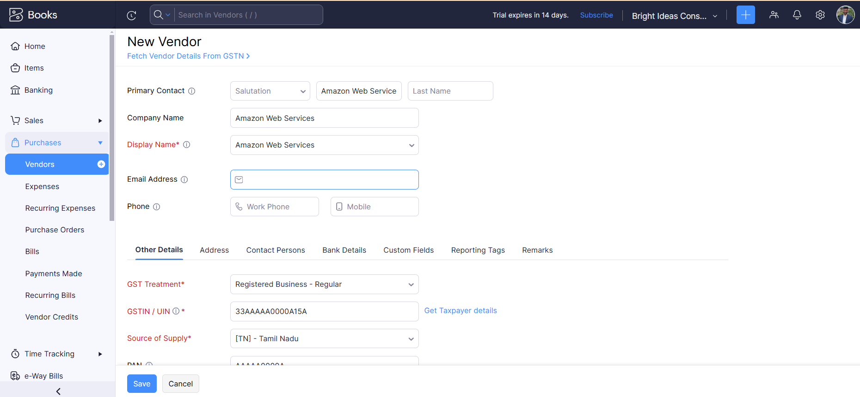**Amazon Web Services**
2. 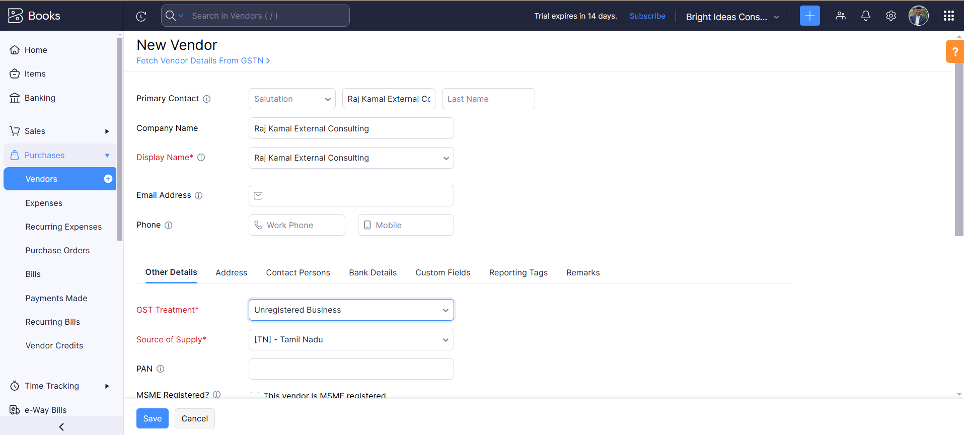Raj Kamal External Consulting

**Activity 2: Review of Vendors List**

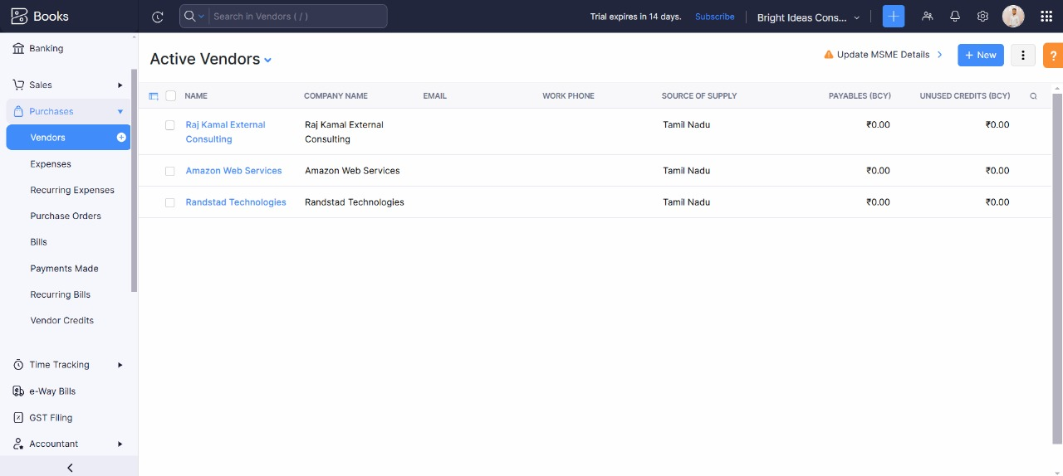

Here we successfully created all the vendors that are:

1. Randstad Technologies (GST registered)

2. Amazon Web Services (GST registered)

3. Raj Kamal External Consulting (Non GST)

* **Milestone 4: Purchases**

**Activity 1: Purchase Order Creation**

Bright Ideas Consulting has raised below purchase orders from the vendors:

1. 05-04-2023 Randstad Technologies – Office Equipment - Qty 20 @ Rs.10,000/- each GST @ 18%

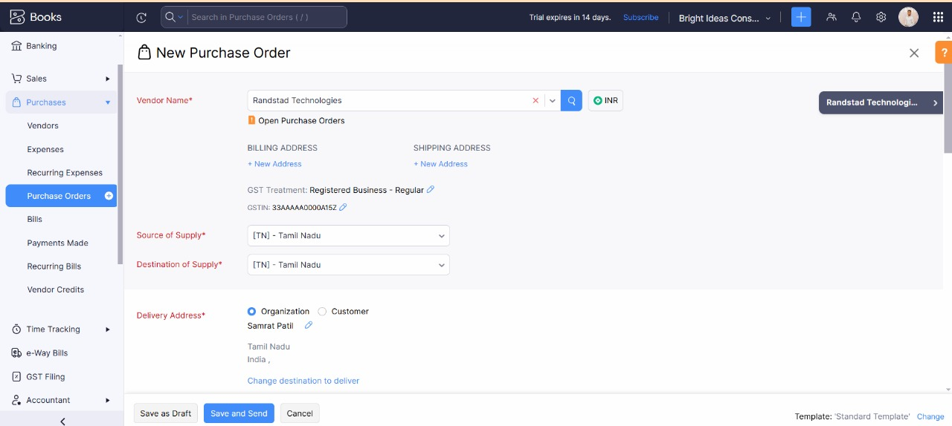

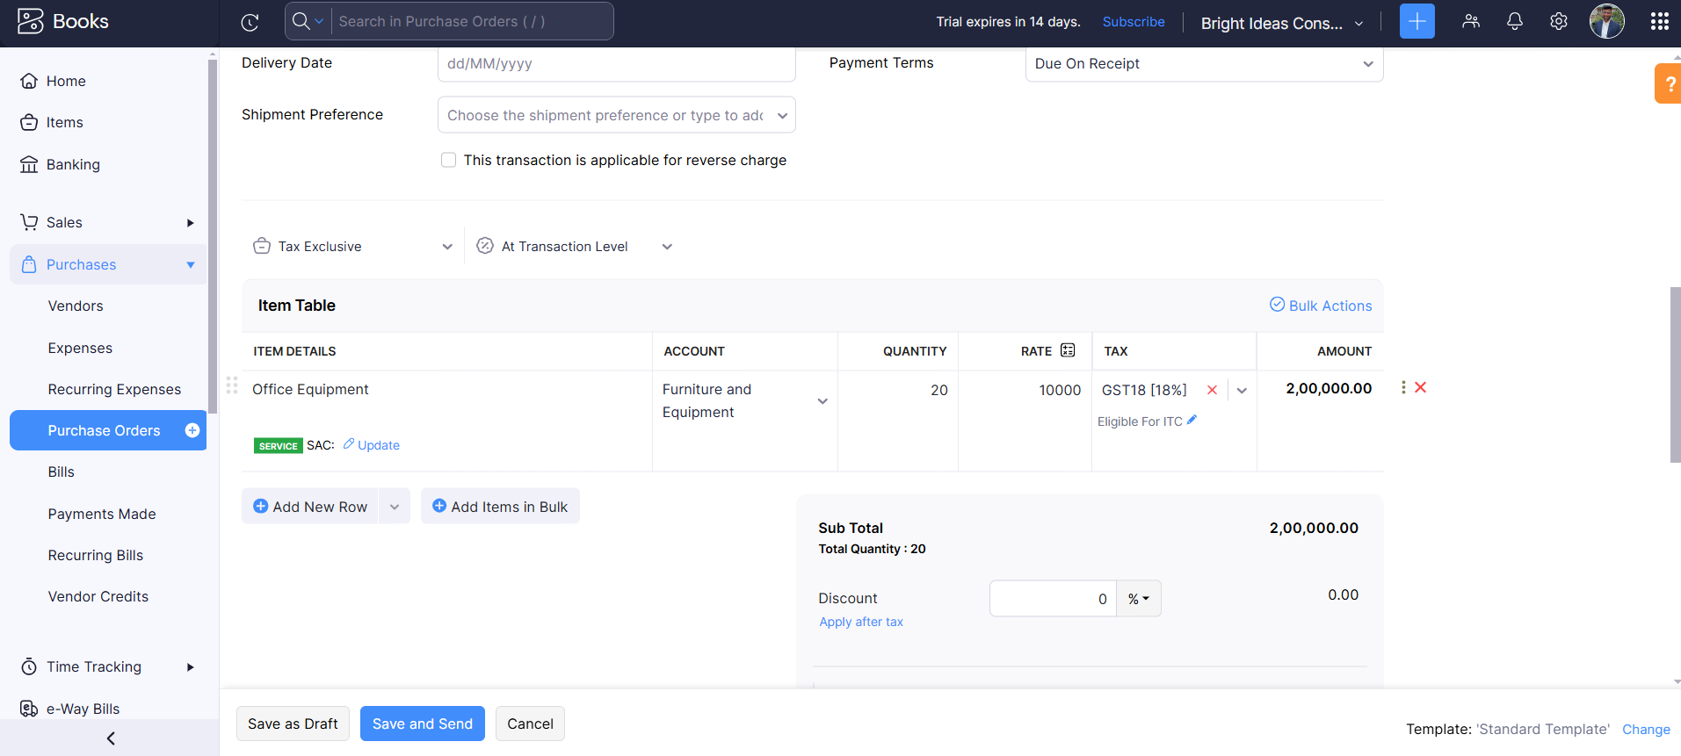

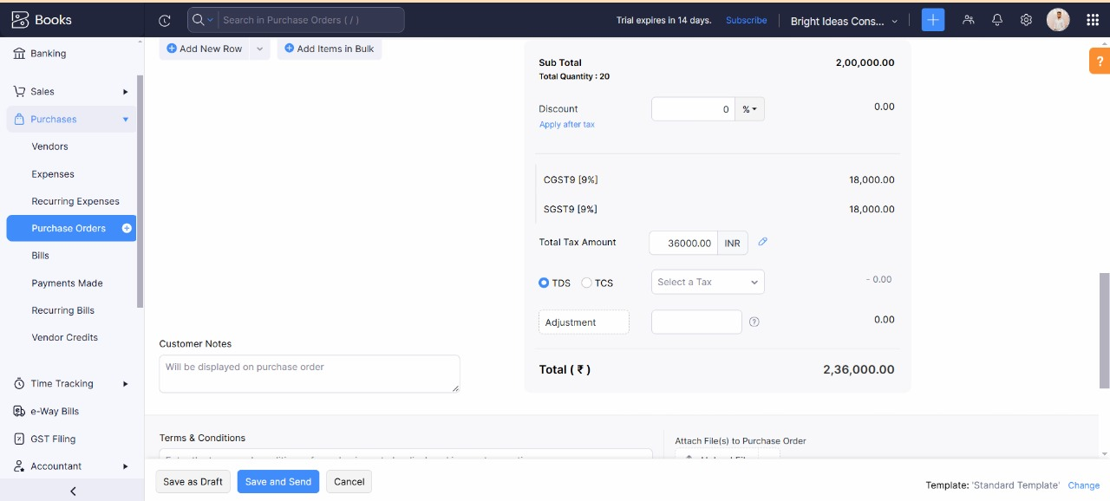

For the Creation of purchase orders from the Navigation Panel we go to Purchases>Purchase Order> Creat New>Provie the respective details>Save on draft

**Activity 2: Purchase Order to Purchase Bills Conversion**

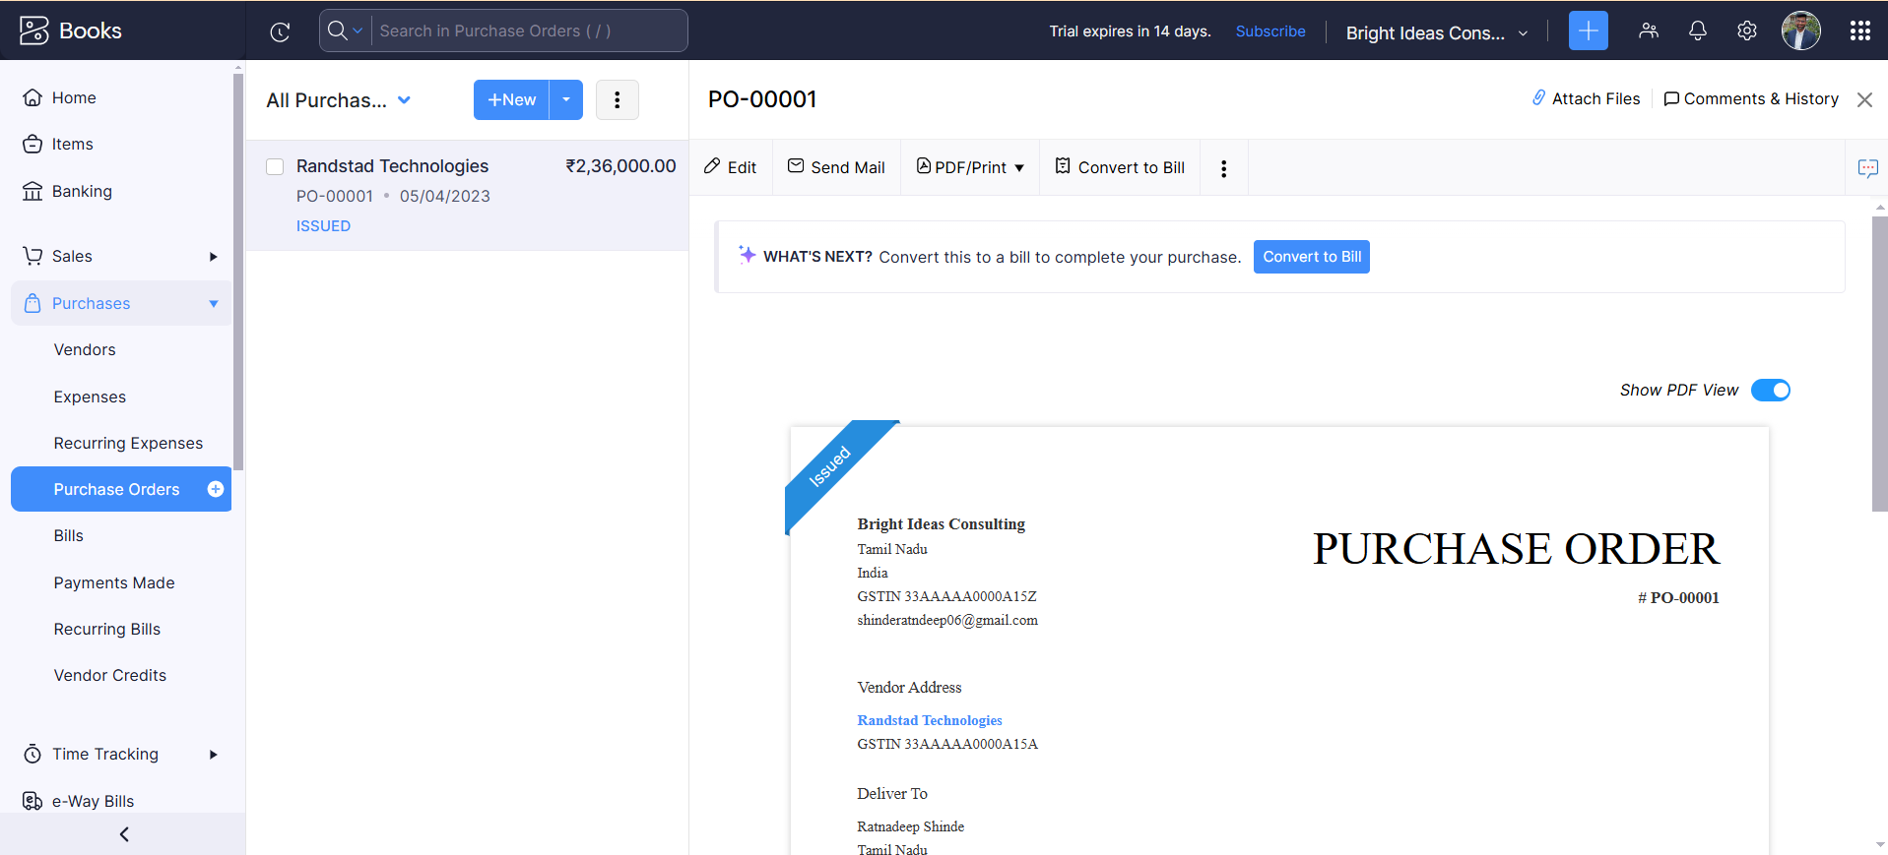

After Creating the Purchase orders, We mark them as Issued and then PO as “Convert to Bill” to convert the same as bill entry:

We Enter the Date of the Bill as 05-04-2023 and then click on Save as open.

**Activity 3: Direct Vendor Purchases Bills Creation:**

Bright Ideas Consulting availed the services from the below Suppliers:

1. **10-04-2023 Cloud Database From Amazon Wed Services- Rs.50,000/- pm GST @ 18%**

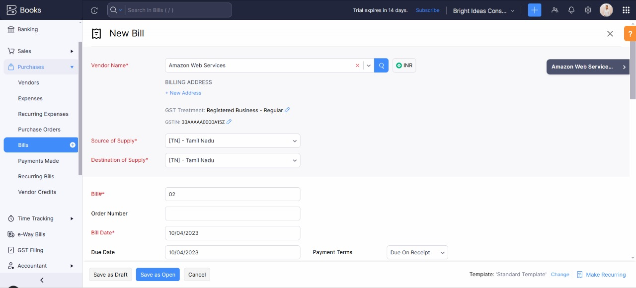

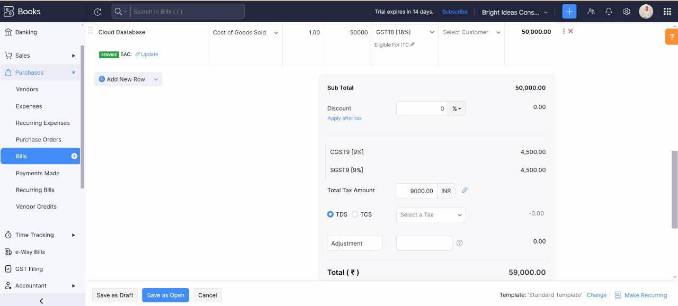

To create direct purchase invoices for the above transaction from the navigation panel we go to: Purchases>Bills>Create New>Enter the details>Click on Save Open

1. 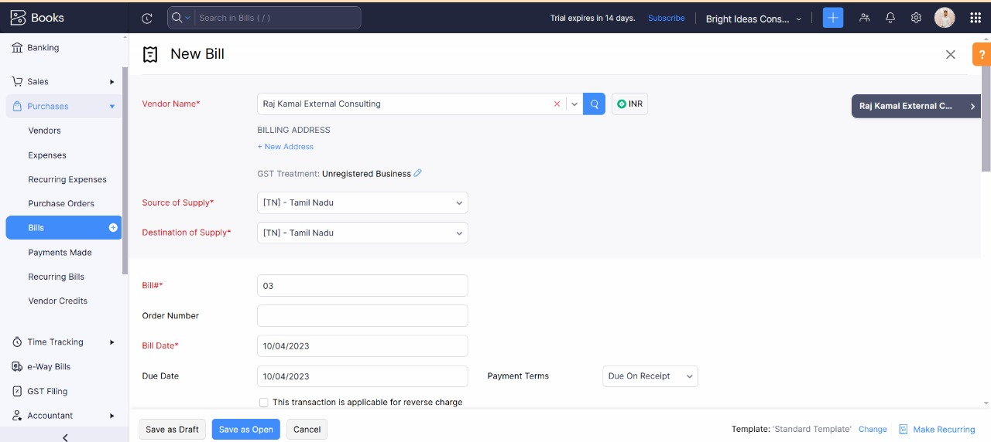**10-04-2023 Consultancy Services from Raj Kamal External Consulting - Rs.1,00,000/- pm**

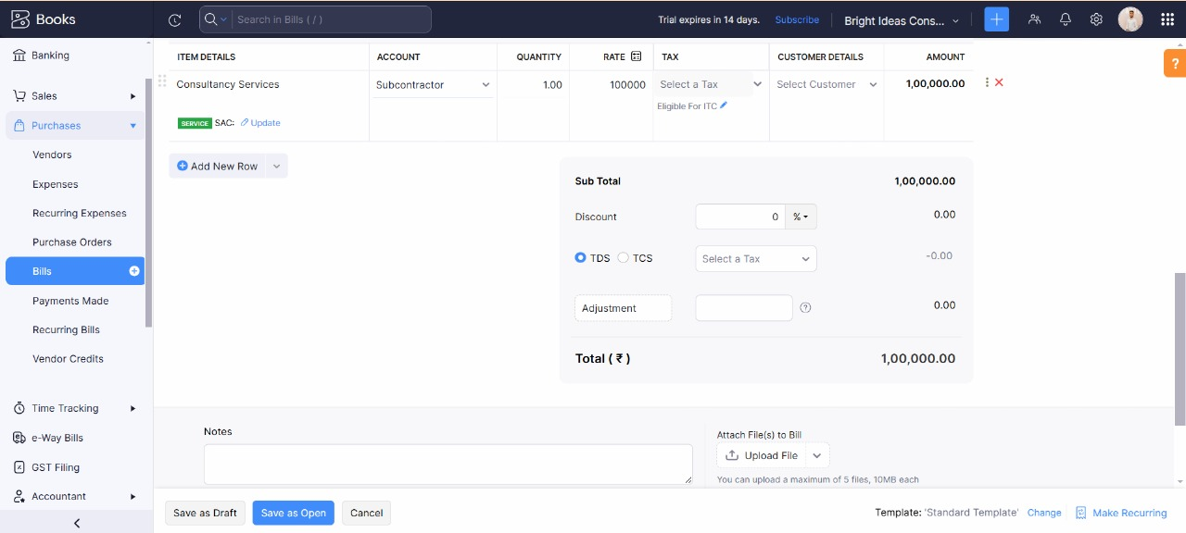

Here we complete the Direct Vendor Purchases bill Creation that Bright Ideas Consulting availed the services from the below Suppliers:

1. 10-04-2023 Cloud Database From Amazon Wed Services- Rs.50,000/- pm GST @ 18%

2. 10-04-2023 Consultancy Services from Raj Kamal External Consulting - Rs.1,00,000/- pm

**Activity 4: Reconciliation of Open & Outstanding Bills**

For Open & Outstanding Bills payments need to be marked as and when amounts are paid through the bank account**.**

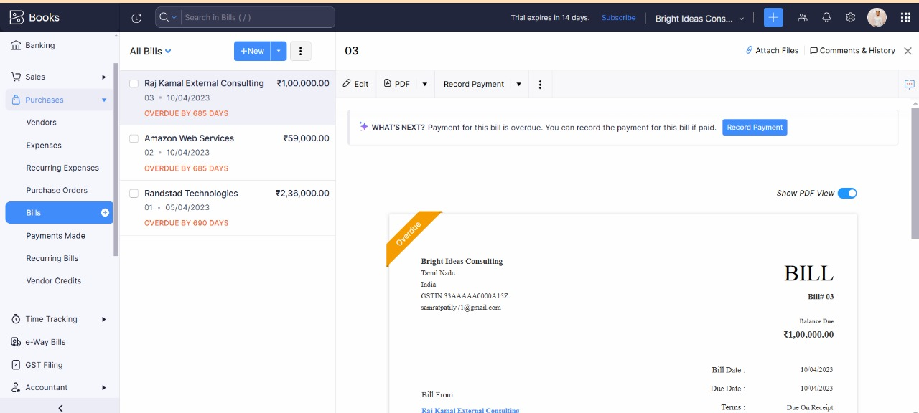

* **Milestone 5: Customers**

**Activity 1: Customers Creation:**

1. 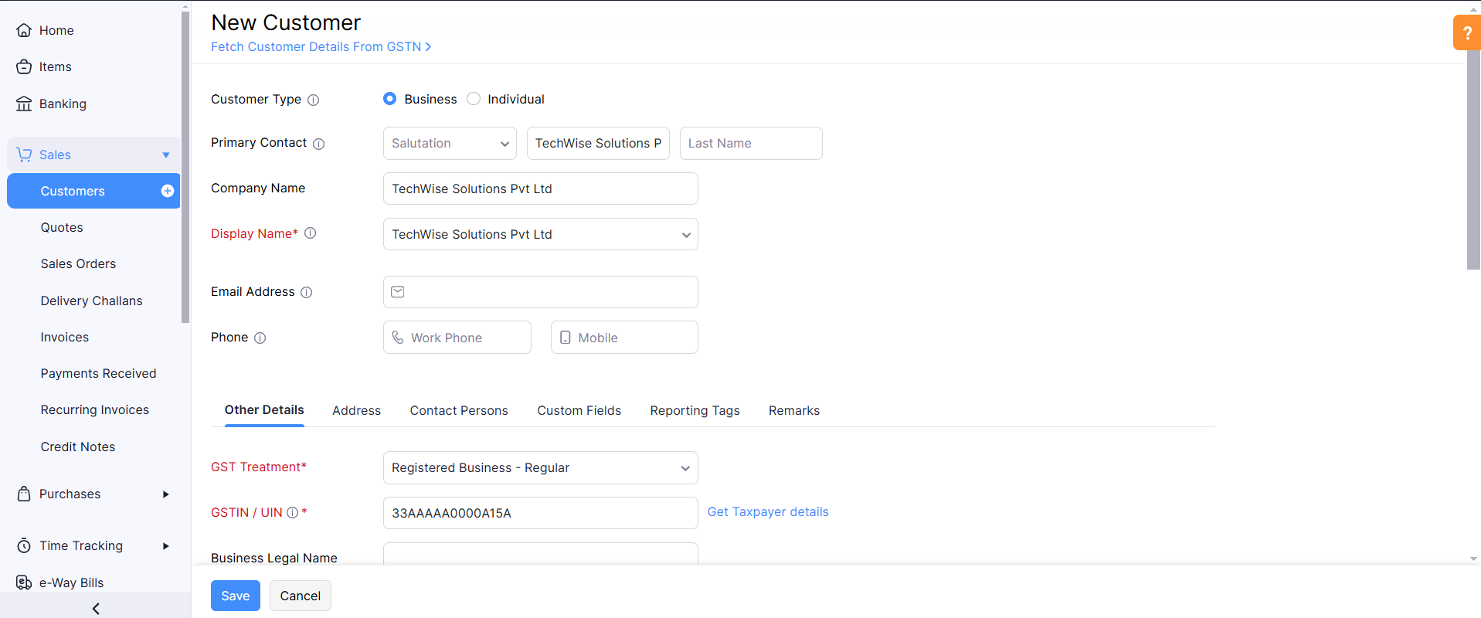TechWise Solutions Pvt Ltd :

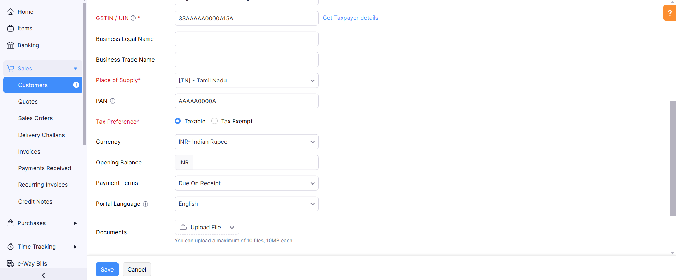

* Firstly, we create a customer account: By going to SALES>CUSTOMERS>CREATE NEW CUSTOMERS and follow the same for the next customers.

1. SmartTech Innovations

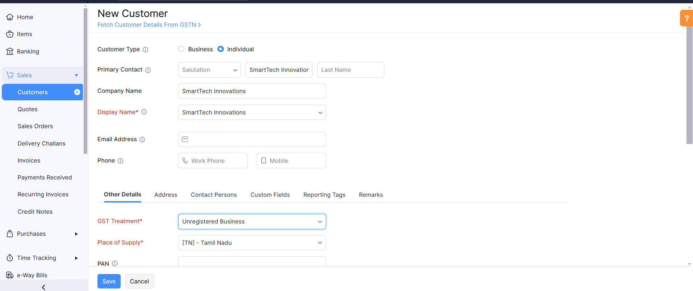

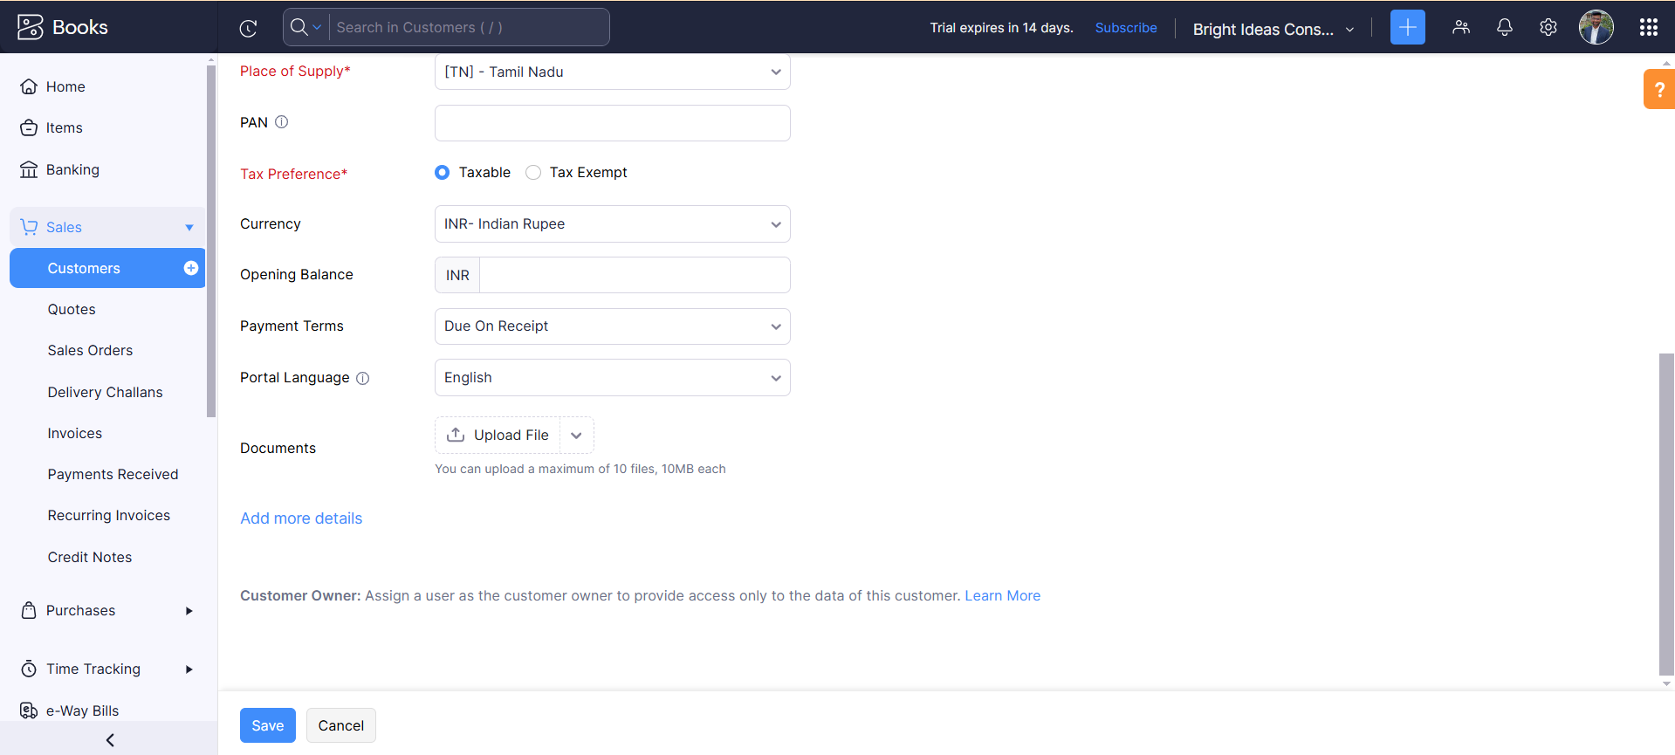

**Activity 2: Review the Customer's List**

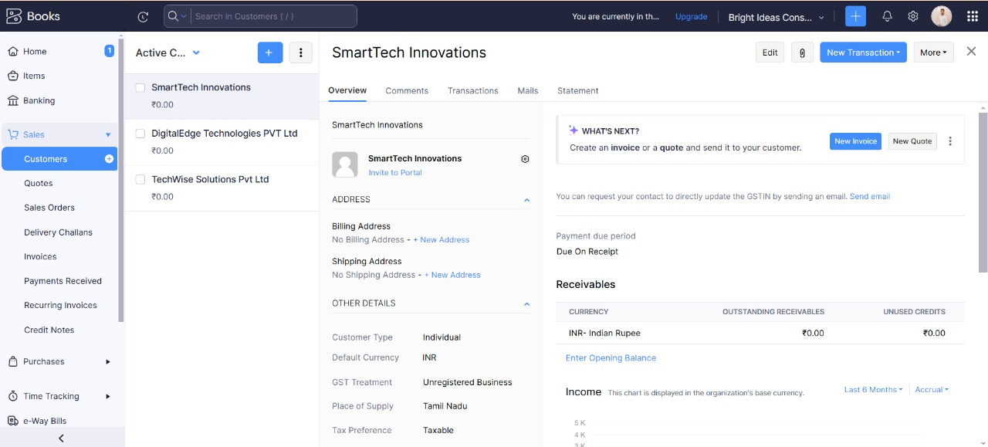

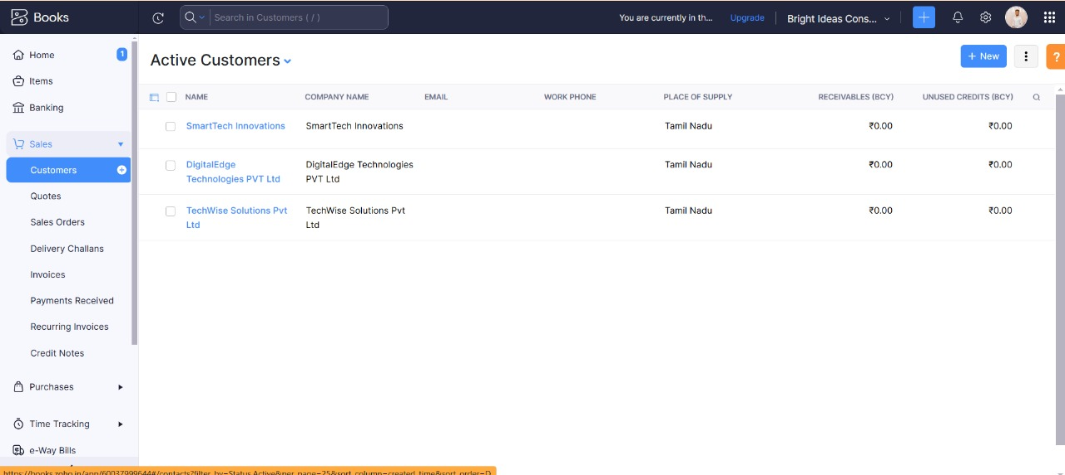

* **Milestone 6: Sales**

**Activity 1: Sales Order Creation**

Bright Ideas Consulting received the below Sales Order from the mentioned Customer:

1. 10/04/2023 TechWise Solutions Pvt Ltd - 100 Hrs of Financial Consultation - paid through bank on 25/04/2023

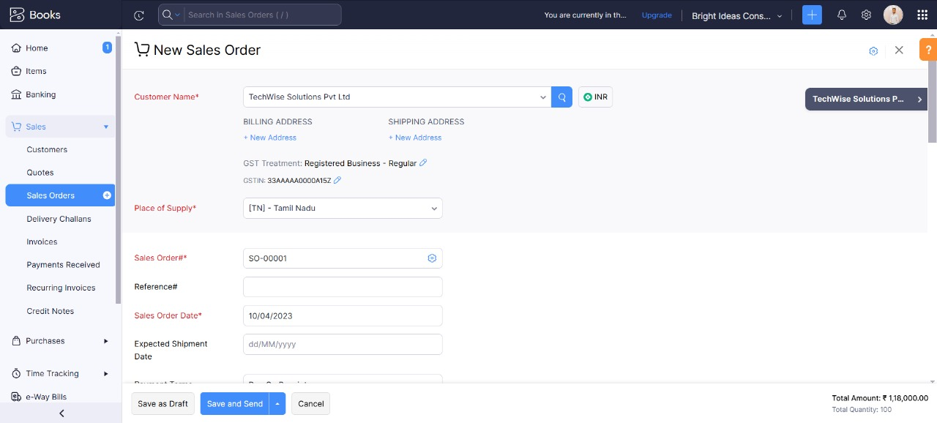

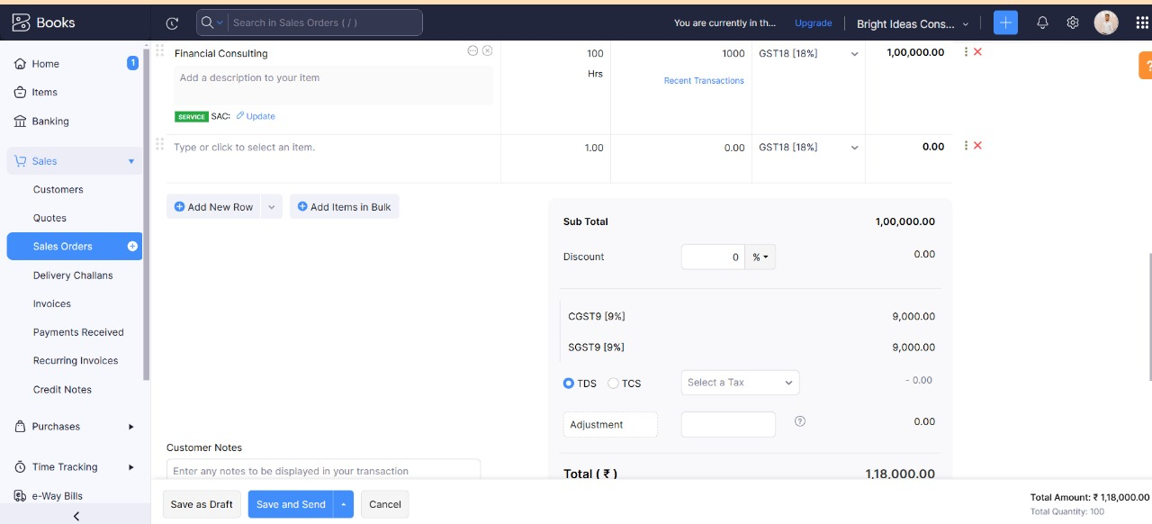

**Activity 2: Sales Order to Sale Invoice Conversion**

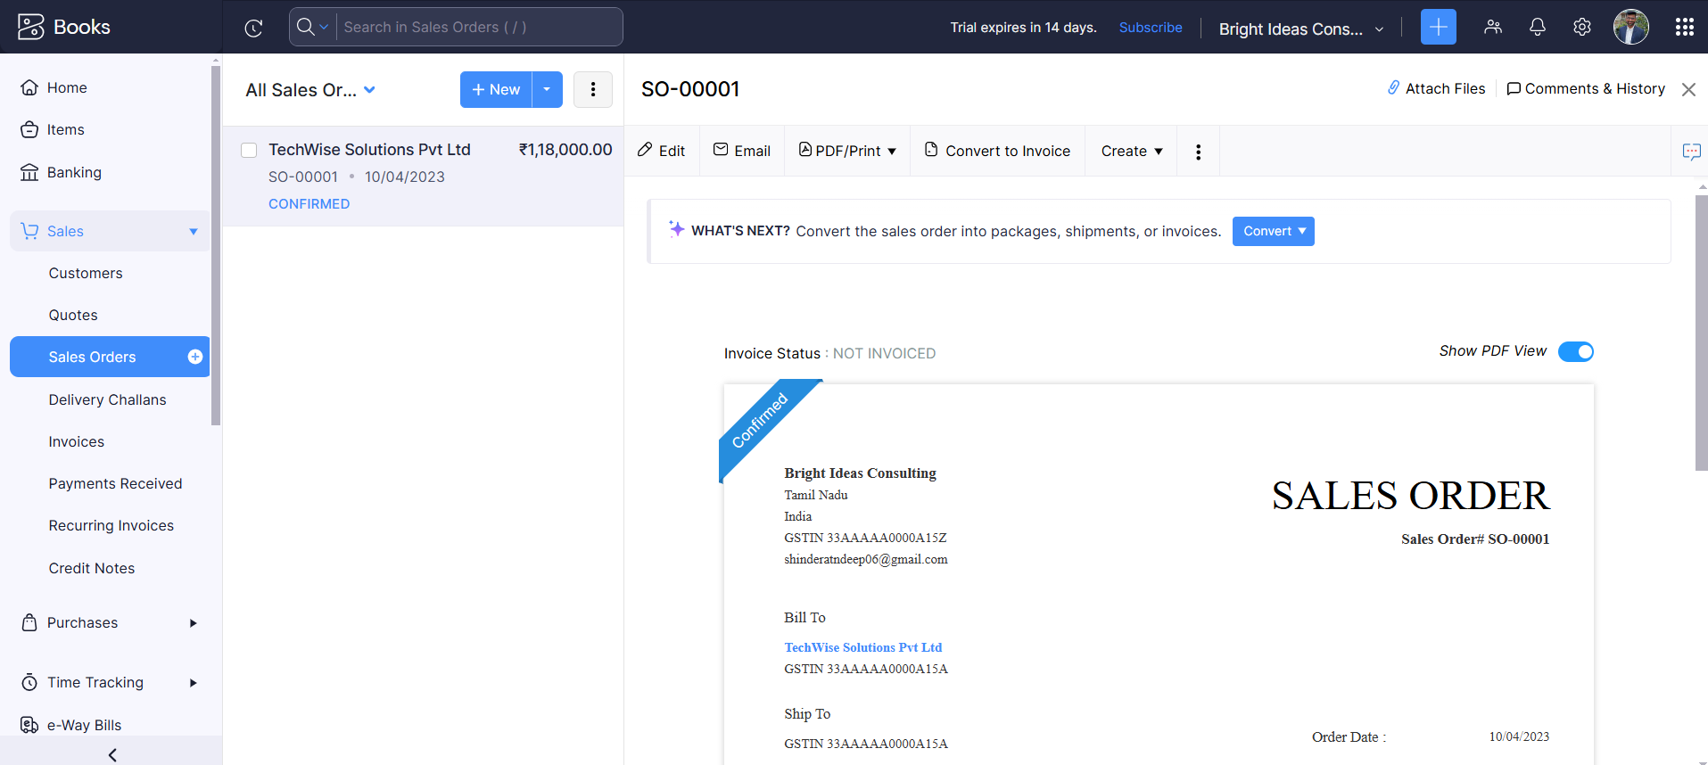

**Activity 3: Direct Sale Invoices**

The below are the direct sale transactions occurred and payments were received in Bank

1. 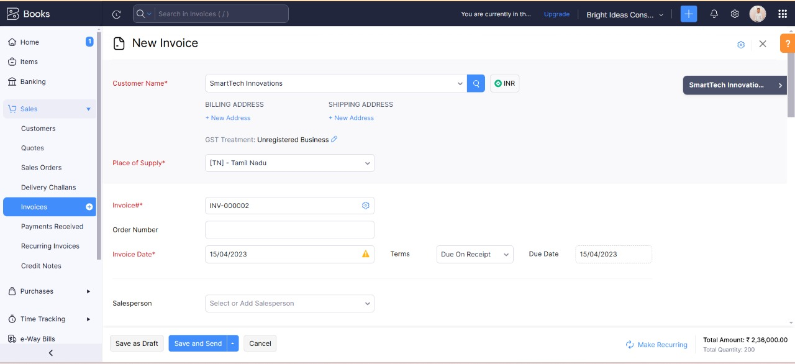15-04-2023 SmartTech Innovations Pvt Ltd- 200Hrs for Financial Consulting

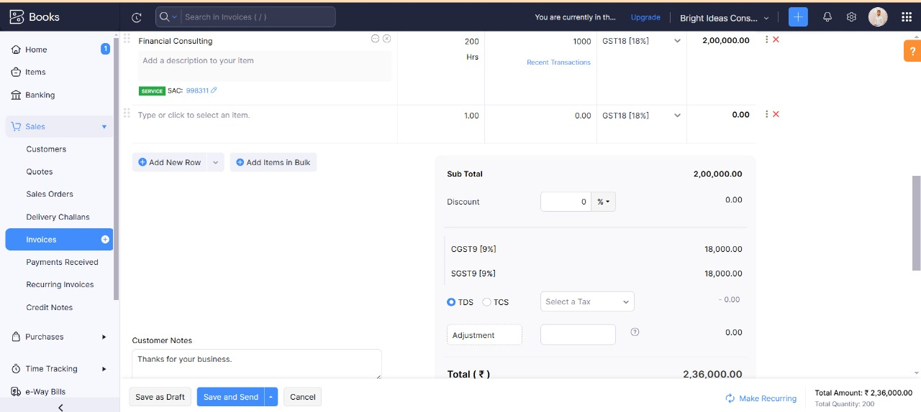

1. 15-04-2023 DigitalEdge Technologies PVT Ltd – 300Hrs for Legal Consulting

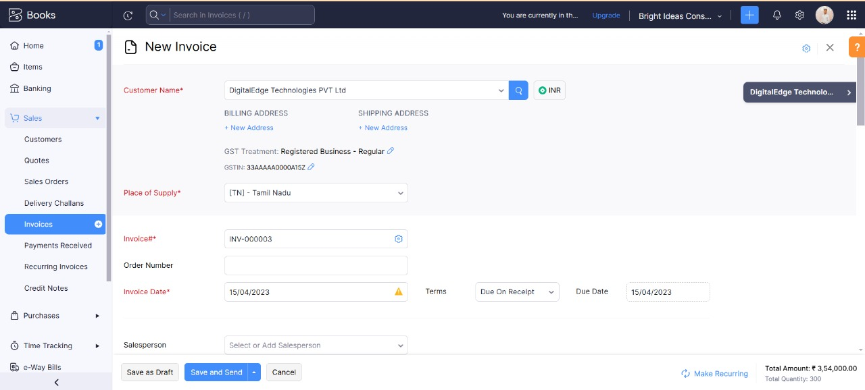

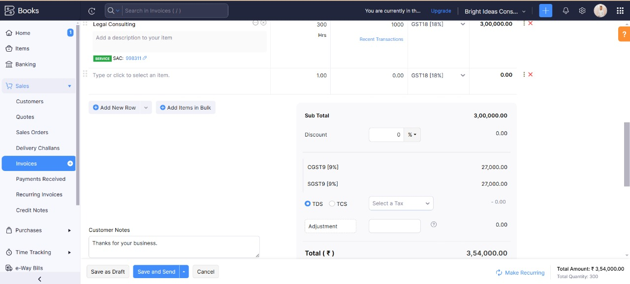

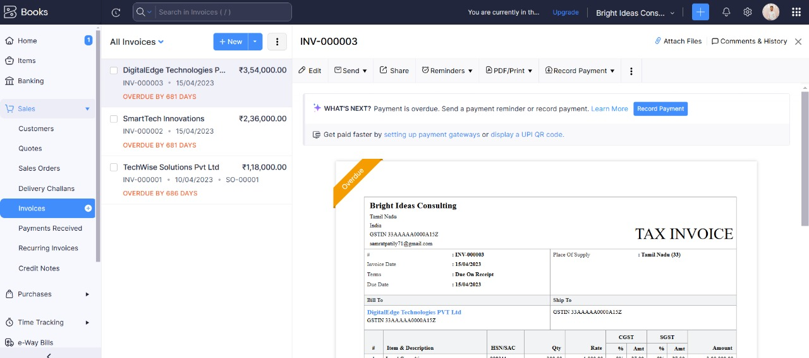

**Activity 4: Reconciliation of Open Invoices**

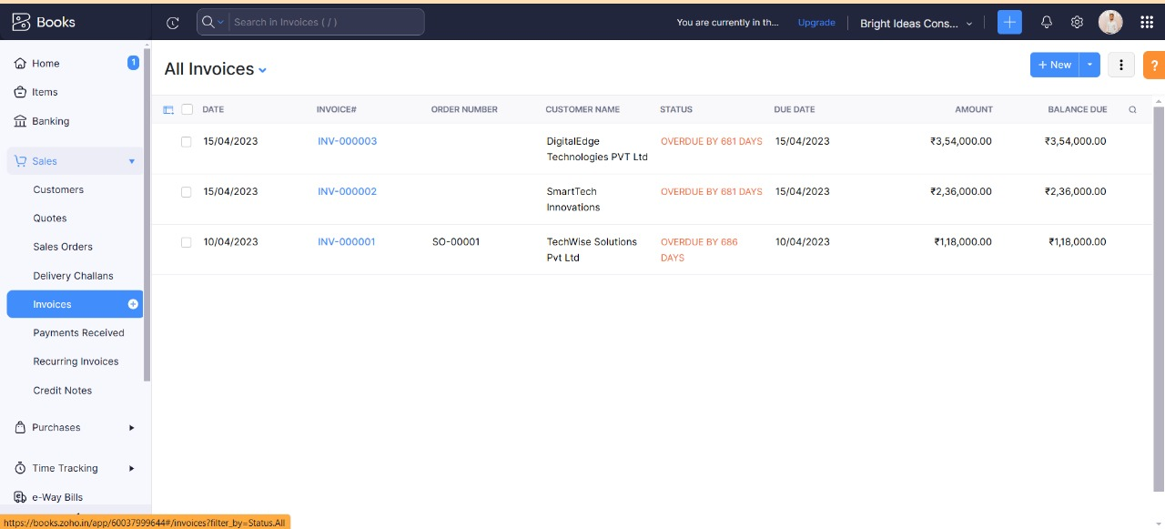

* **Milestone 7: Bank Account**

**Activity 1: Adding Bank Account**

Bright Ideas Consulting has opened an account in ICICI Bank with A/c no 000001

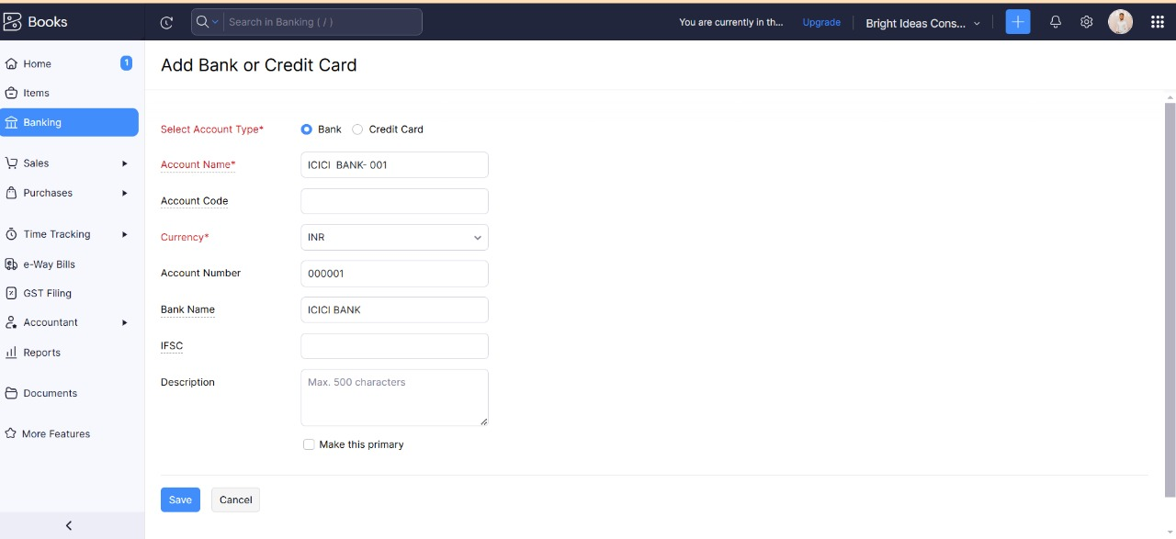

* **Milestone 8: Accounts & Ledgers**

**Activity 1: Creation of New Accounts/Ledgers:**

There will be pre-created Accounts in the Zoho books we need to create the additional Accounts as per our requirement.

We Create these Ledgers: Salary Payable & Rent Payable under Other Current Liabilities

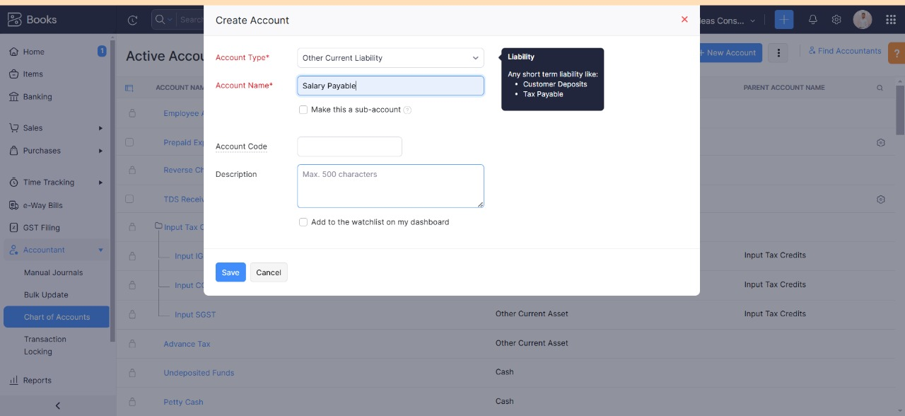

* **Milestone 9: Journal Entries:**

**Activity 1: Recording of Journal Entries**

The below are the Transactions occurred at the end of month:

1. Employee salaries of total Rs.1,00,000/- paid through bank on 30th April 2023.

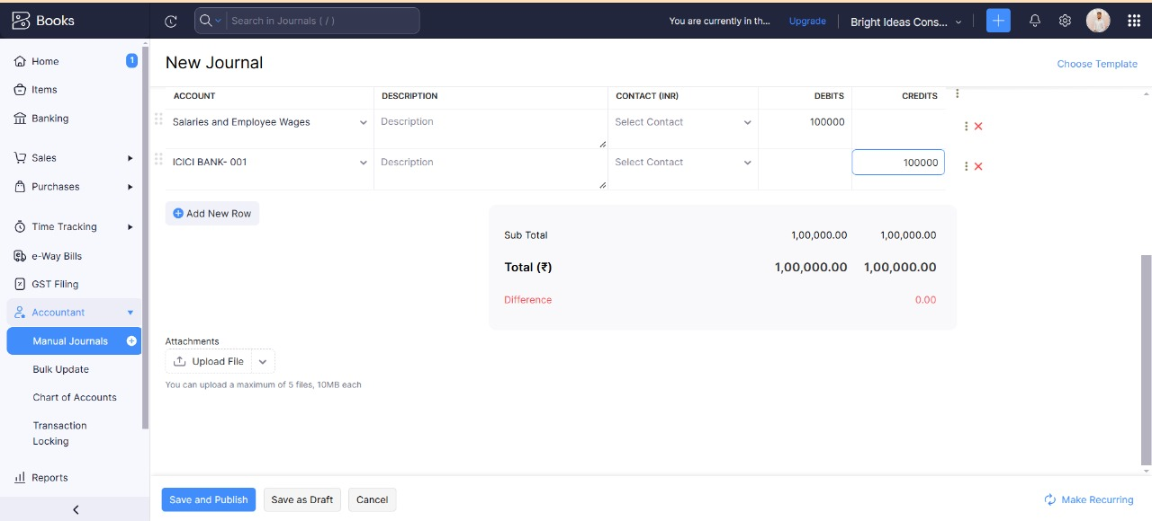

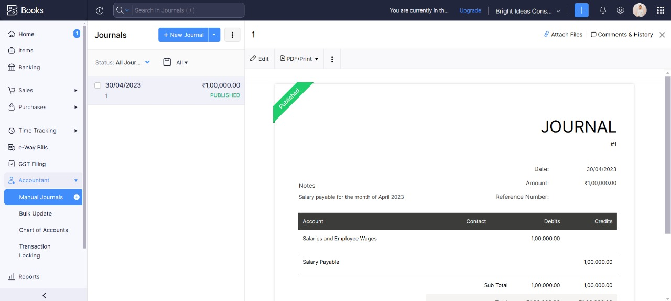

**Milestone 10: Expense & Bills**

**Activity 1: Expense & Bills Entry**

Below are the expenses incurred on 30-04-2023:

1. 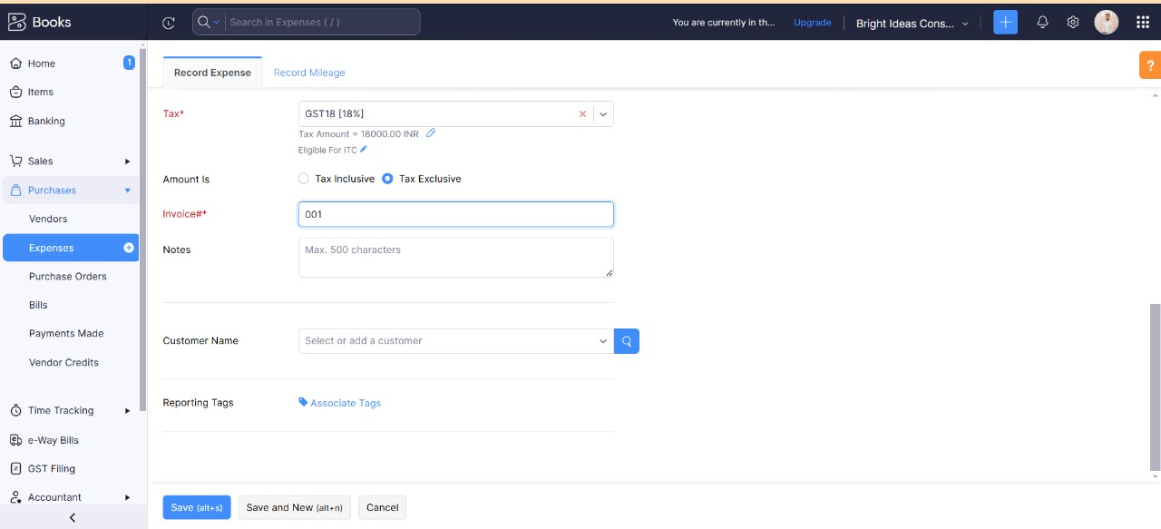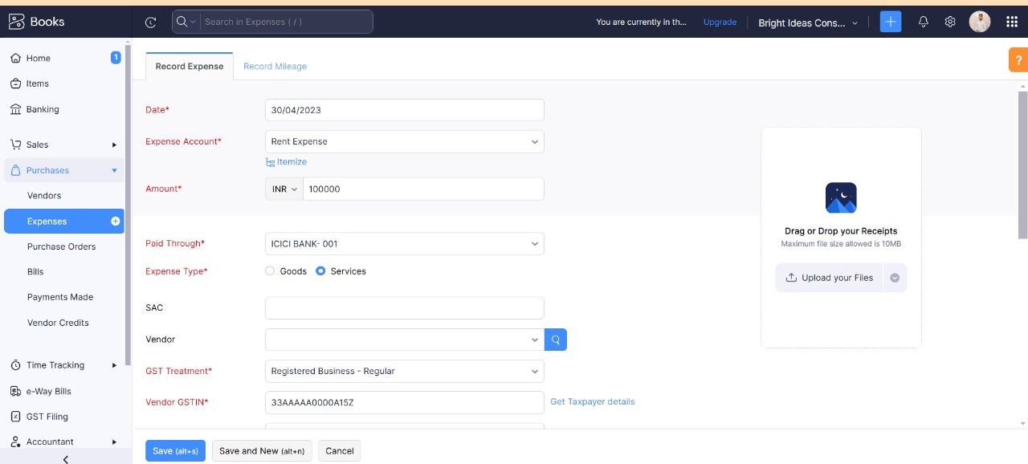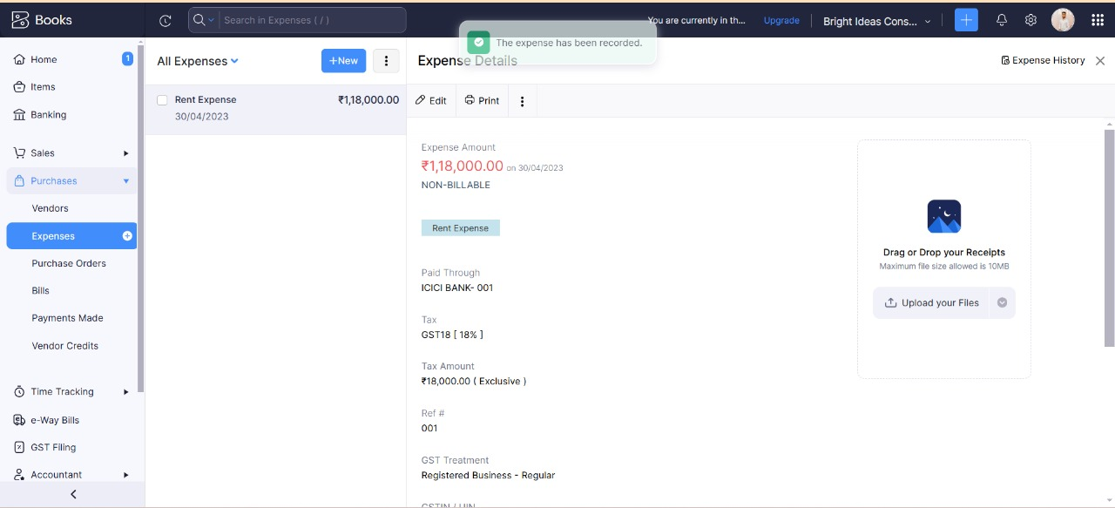Office Rent Rs.1,00,000/- excluding GST @ 18% Total Invoice Value Rs.1,18,000/- paid through Bank on same day.
2. Other Miscellaneous Expenses Rs.5,000/- paid in cash

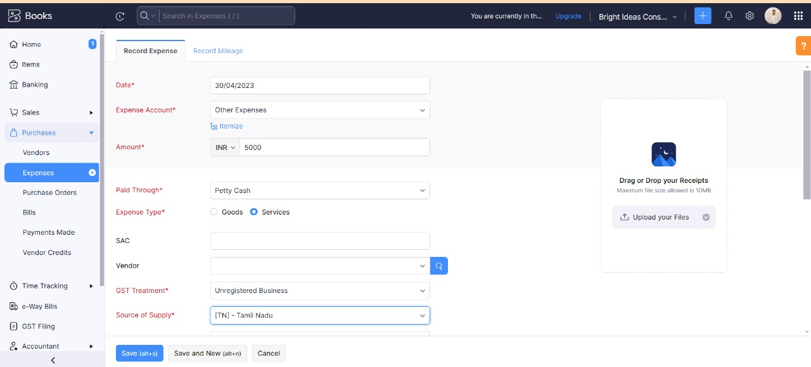

After recording the Expense Entries:

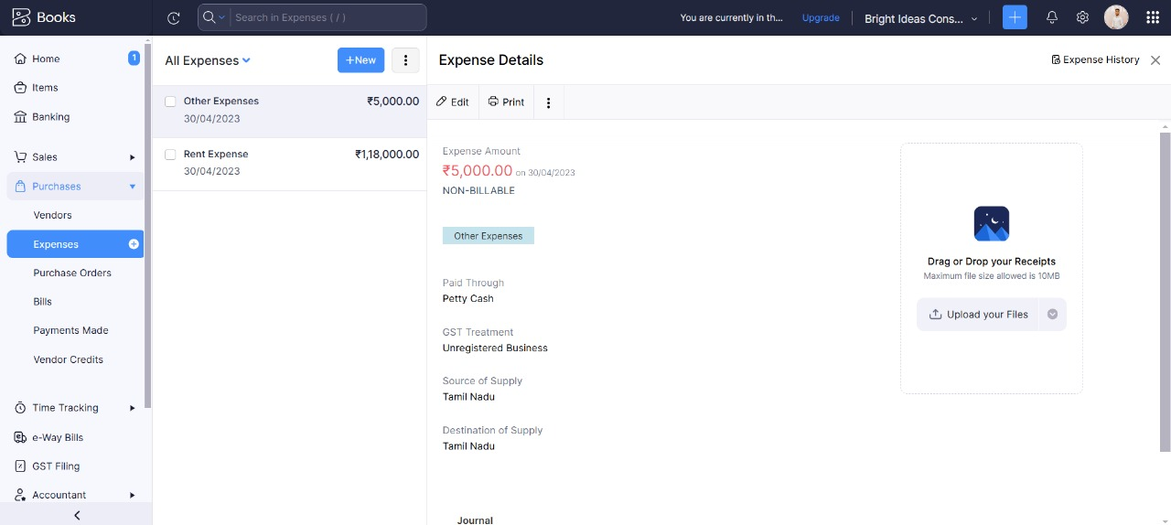

* **Milestone 11: Bank Entries**

The Below are the Bank Transactions occurred during the month:

01-04-2023 Capital Deposit

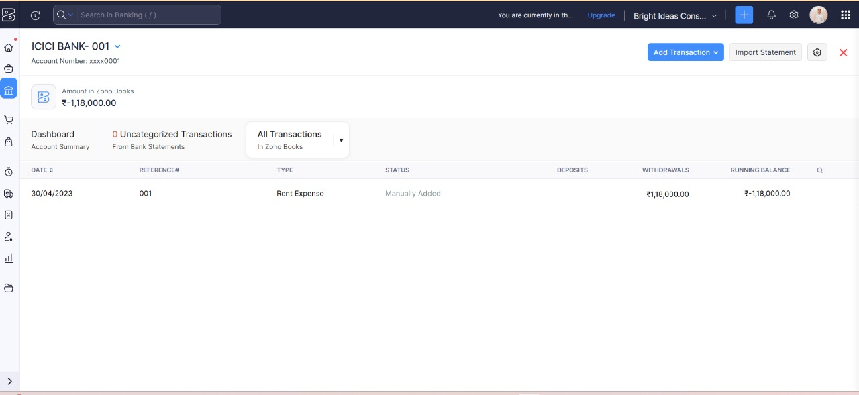

10-04-2023 Petty Cash Withdrawl

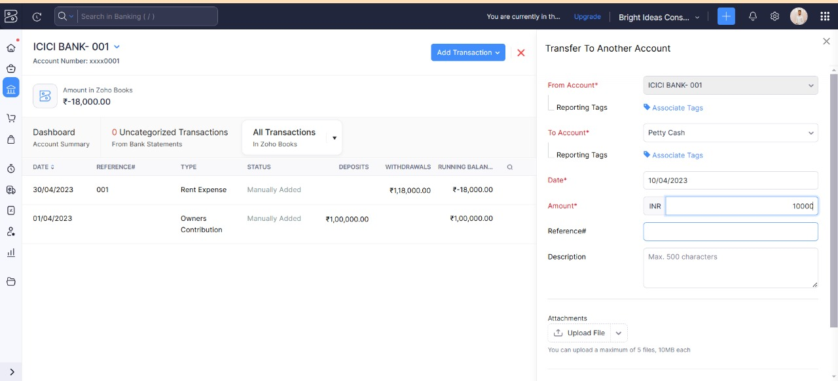

12-04-2023 Amount received from Techwise Solutions

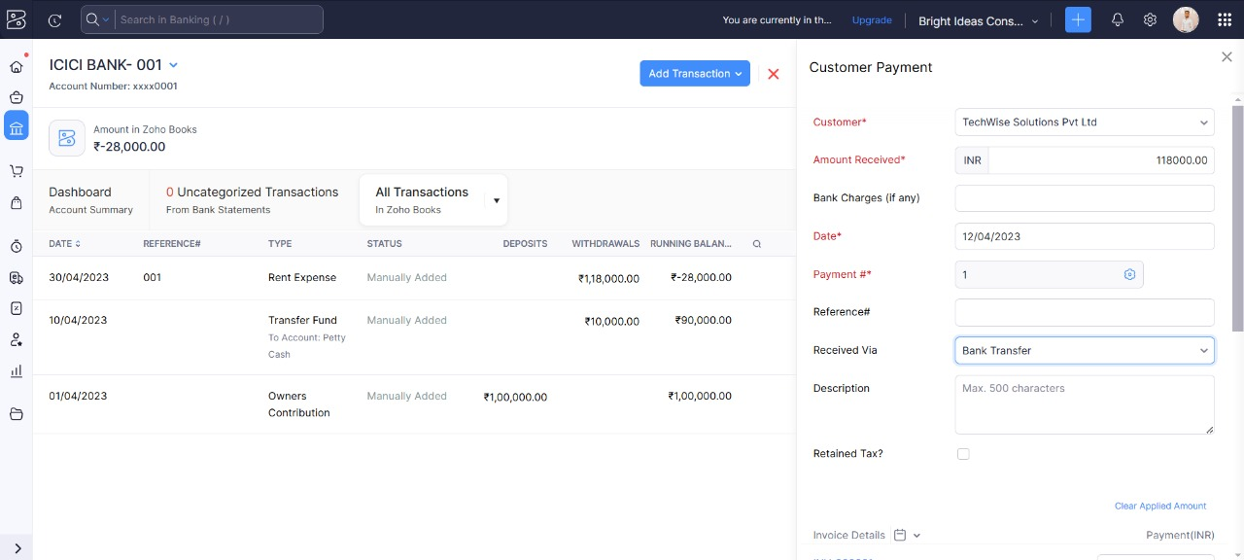

20-04-2023 Amount received from Smart Tech Innovations

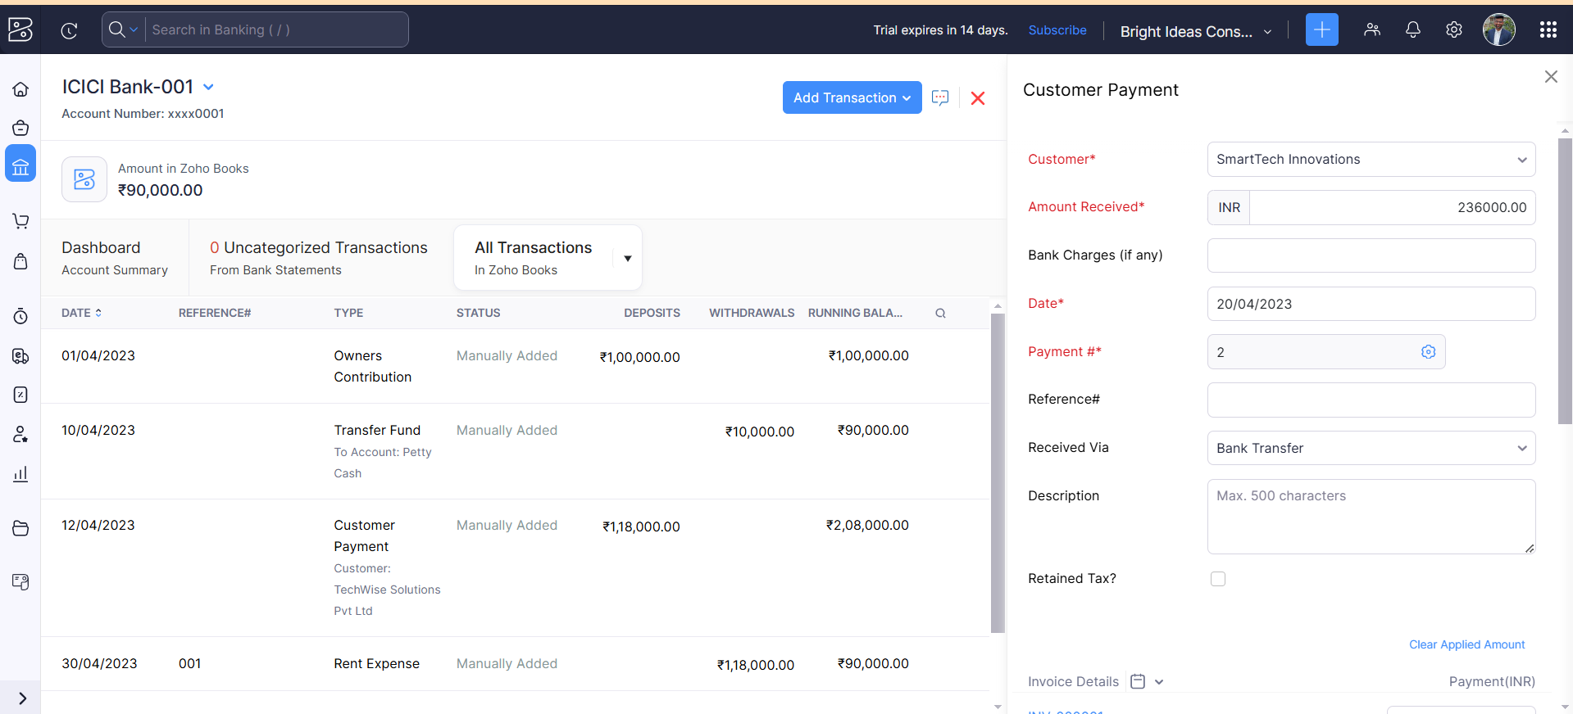

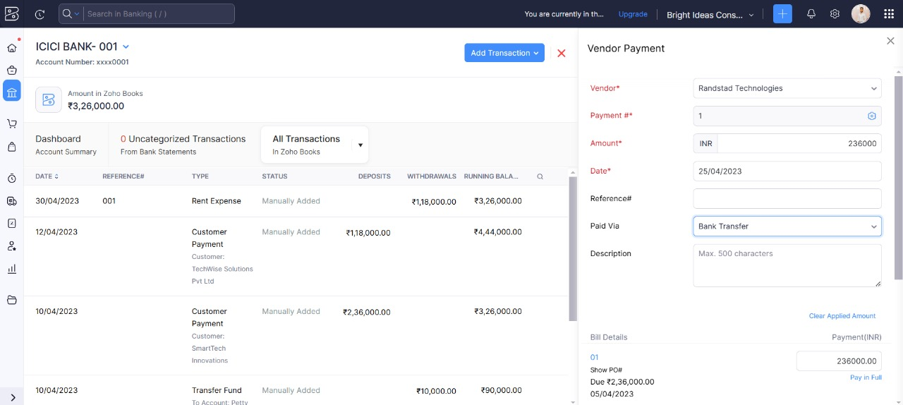25-04-2023 Paid to Rand Stand Technologies

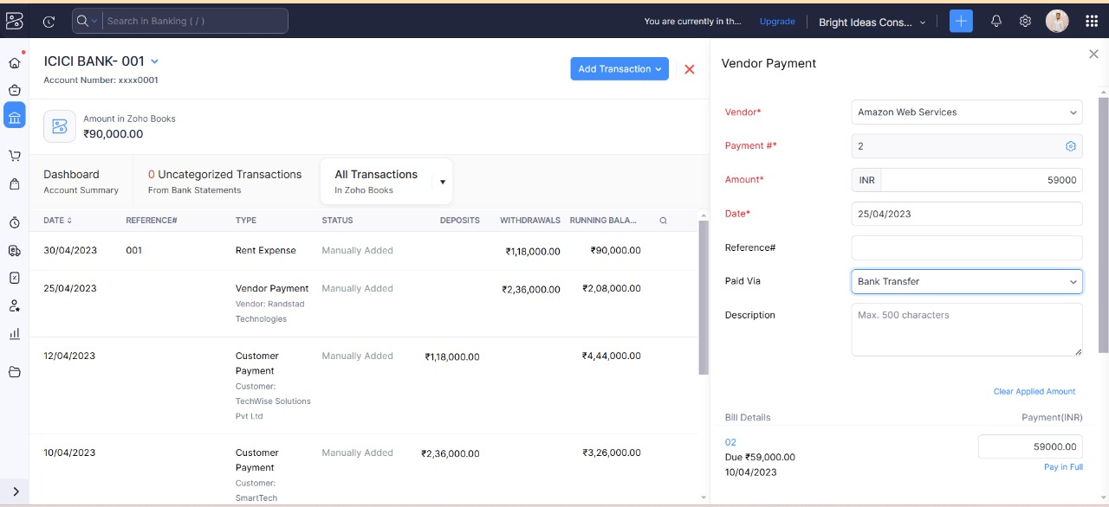25-04-2023 Paid to Amazon Web Services

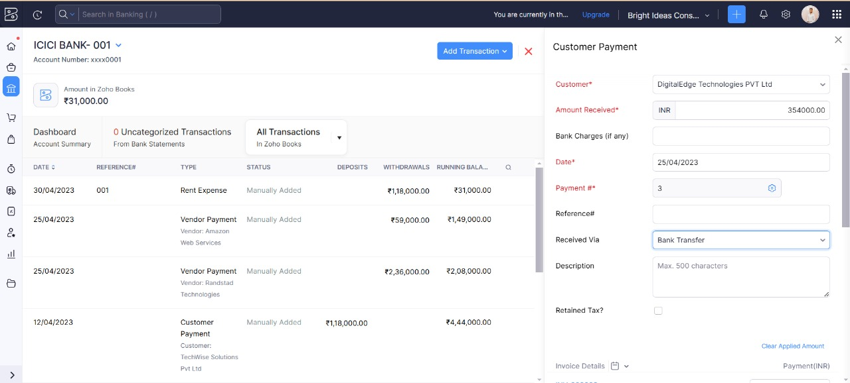25-04-2023 Amount received from DigitalEdge Technologies

25-04-2023 Paid To RajKamal External Consulting

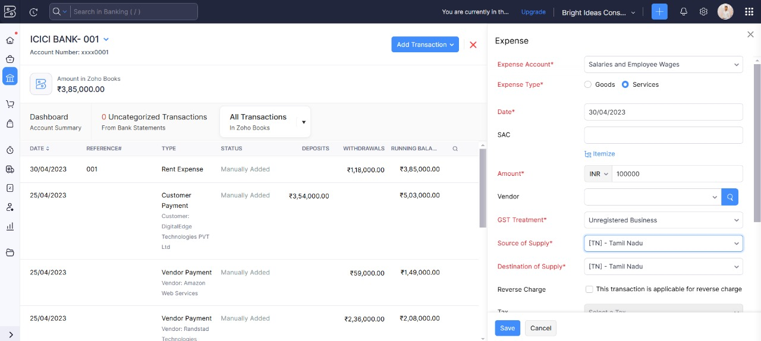

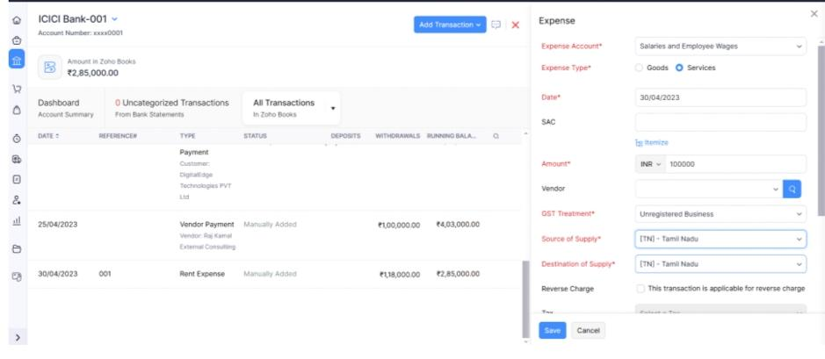30-04-2023 Salary Paid

* **Milestone 12: Financial Reports:**

**Activity 1: Profit and Loss Account**

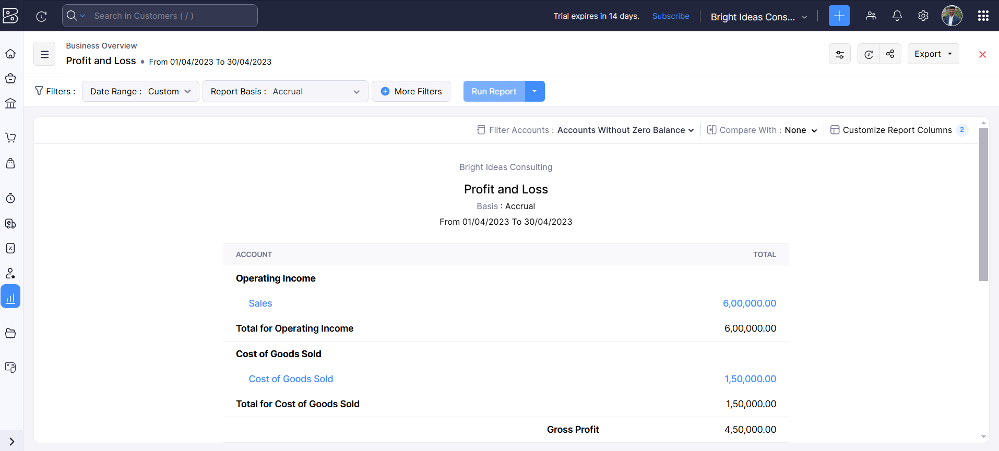

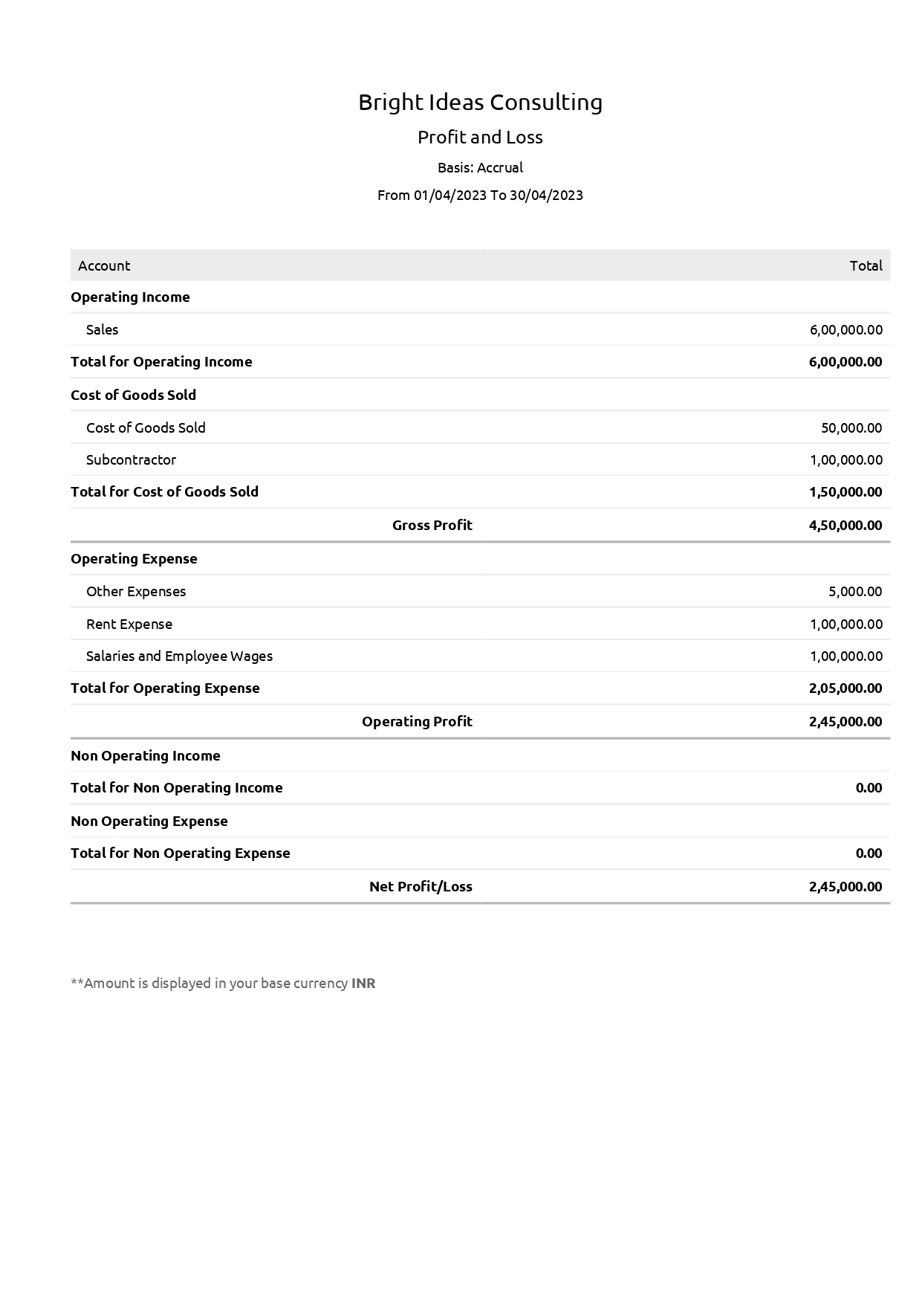

**Activity 2: Balance Sheet**

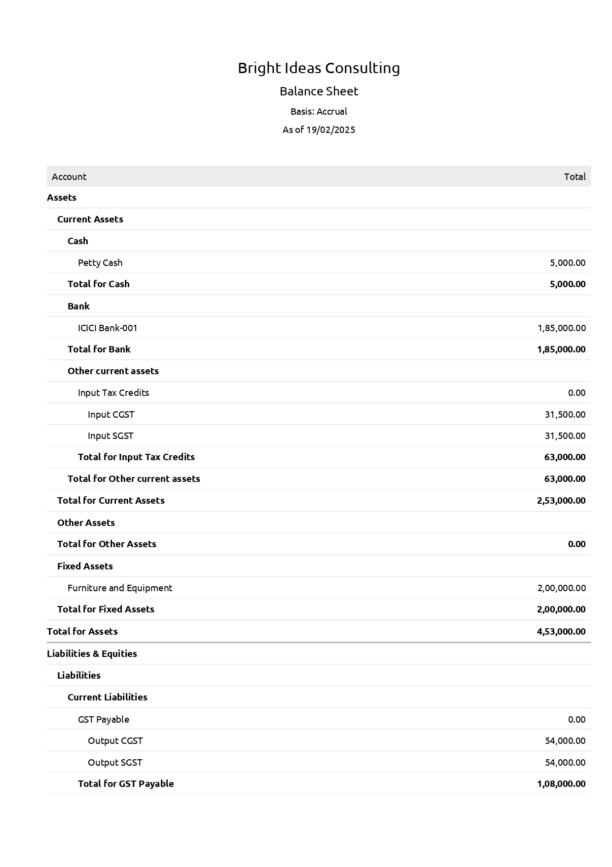

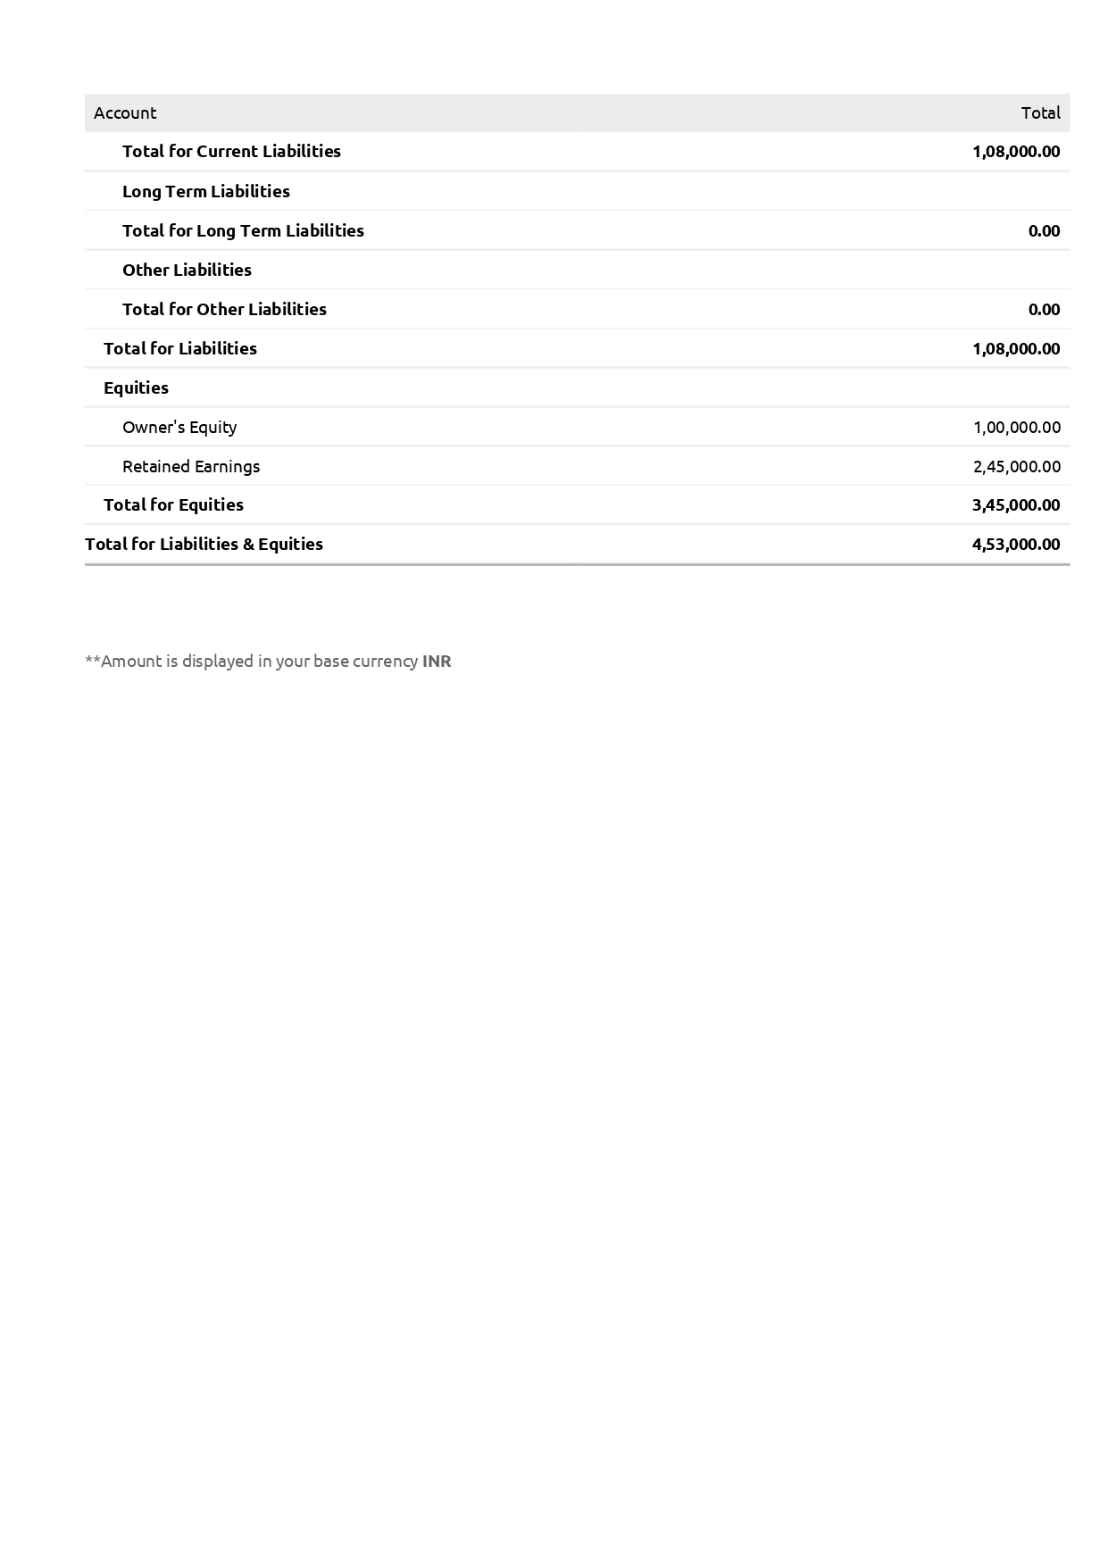

**Activity 3 GSTR- 3B**

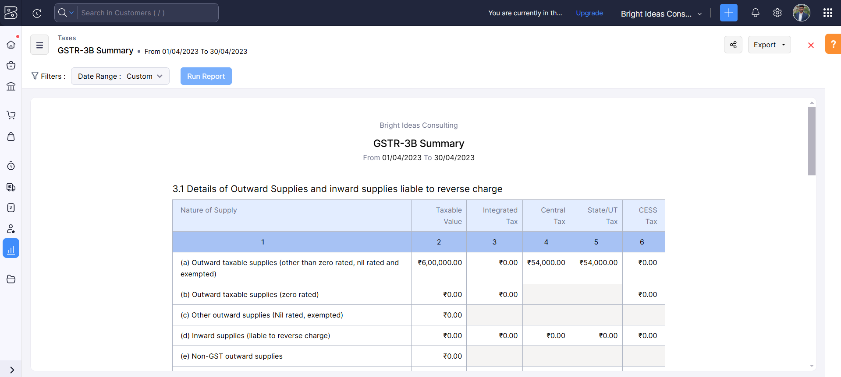

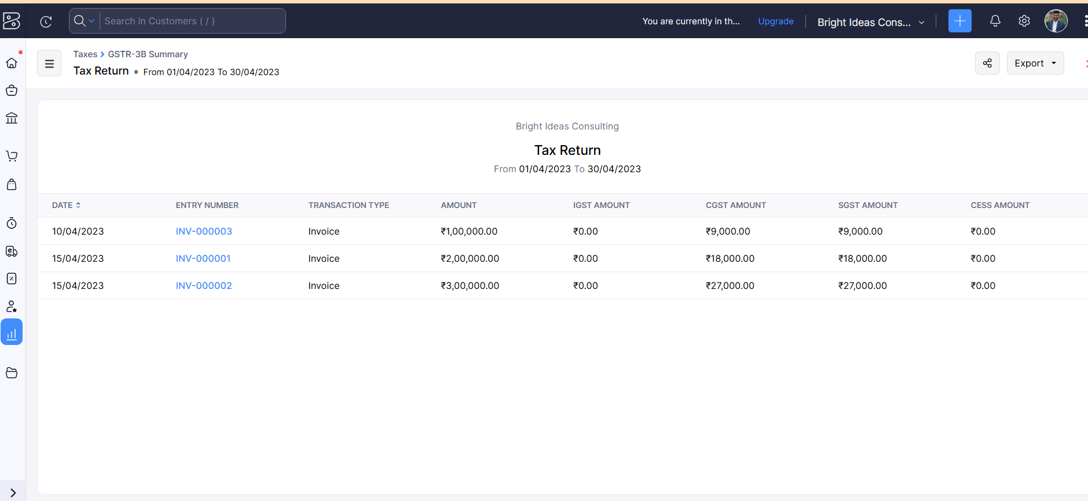

**Activity 4: Journal Report**

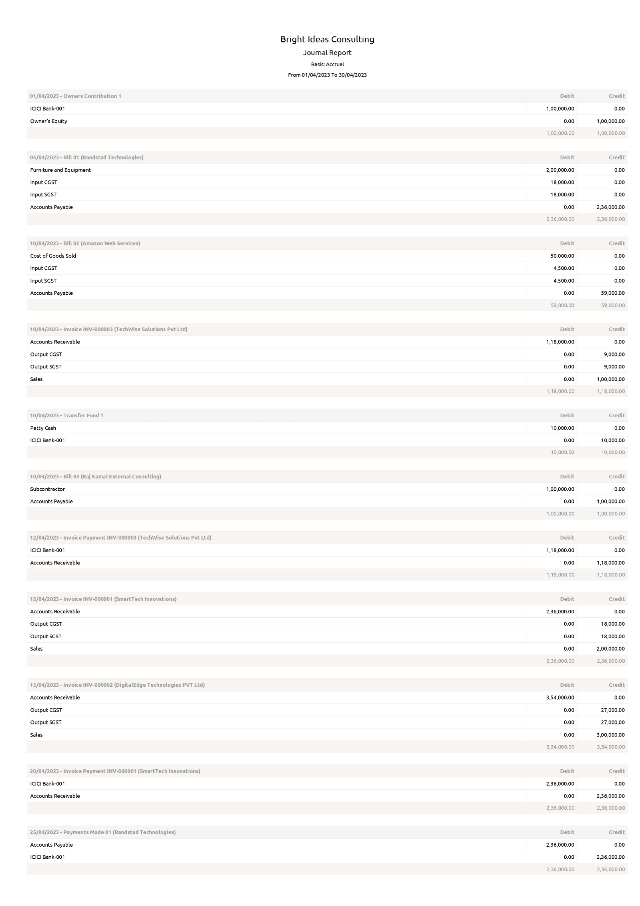

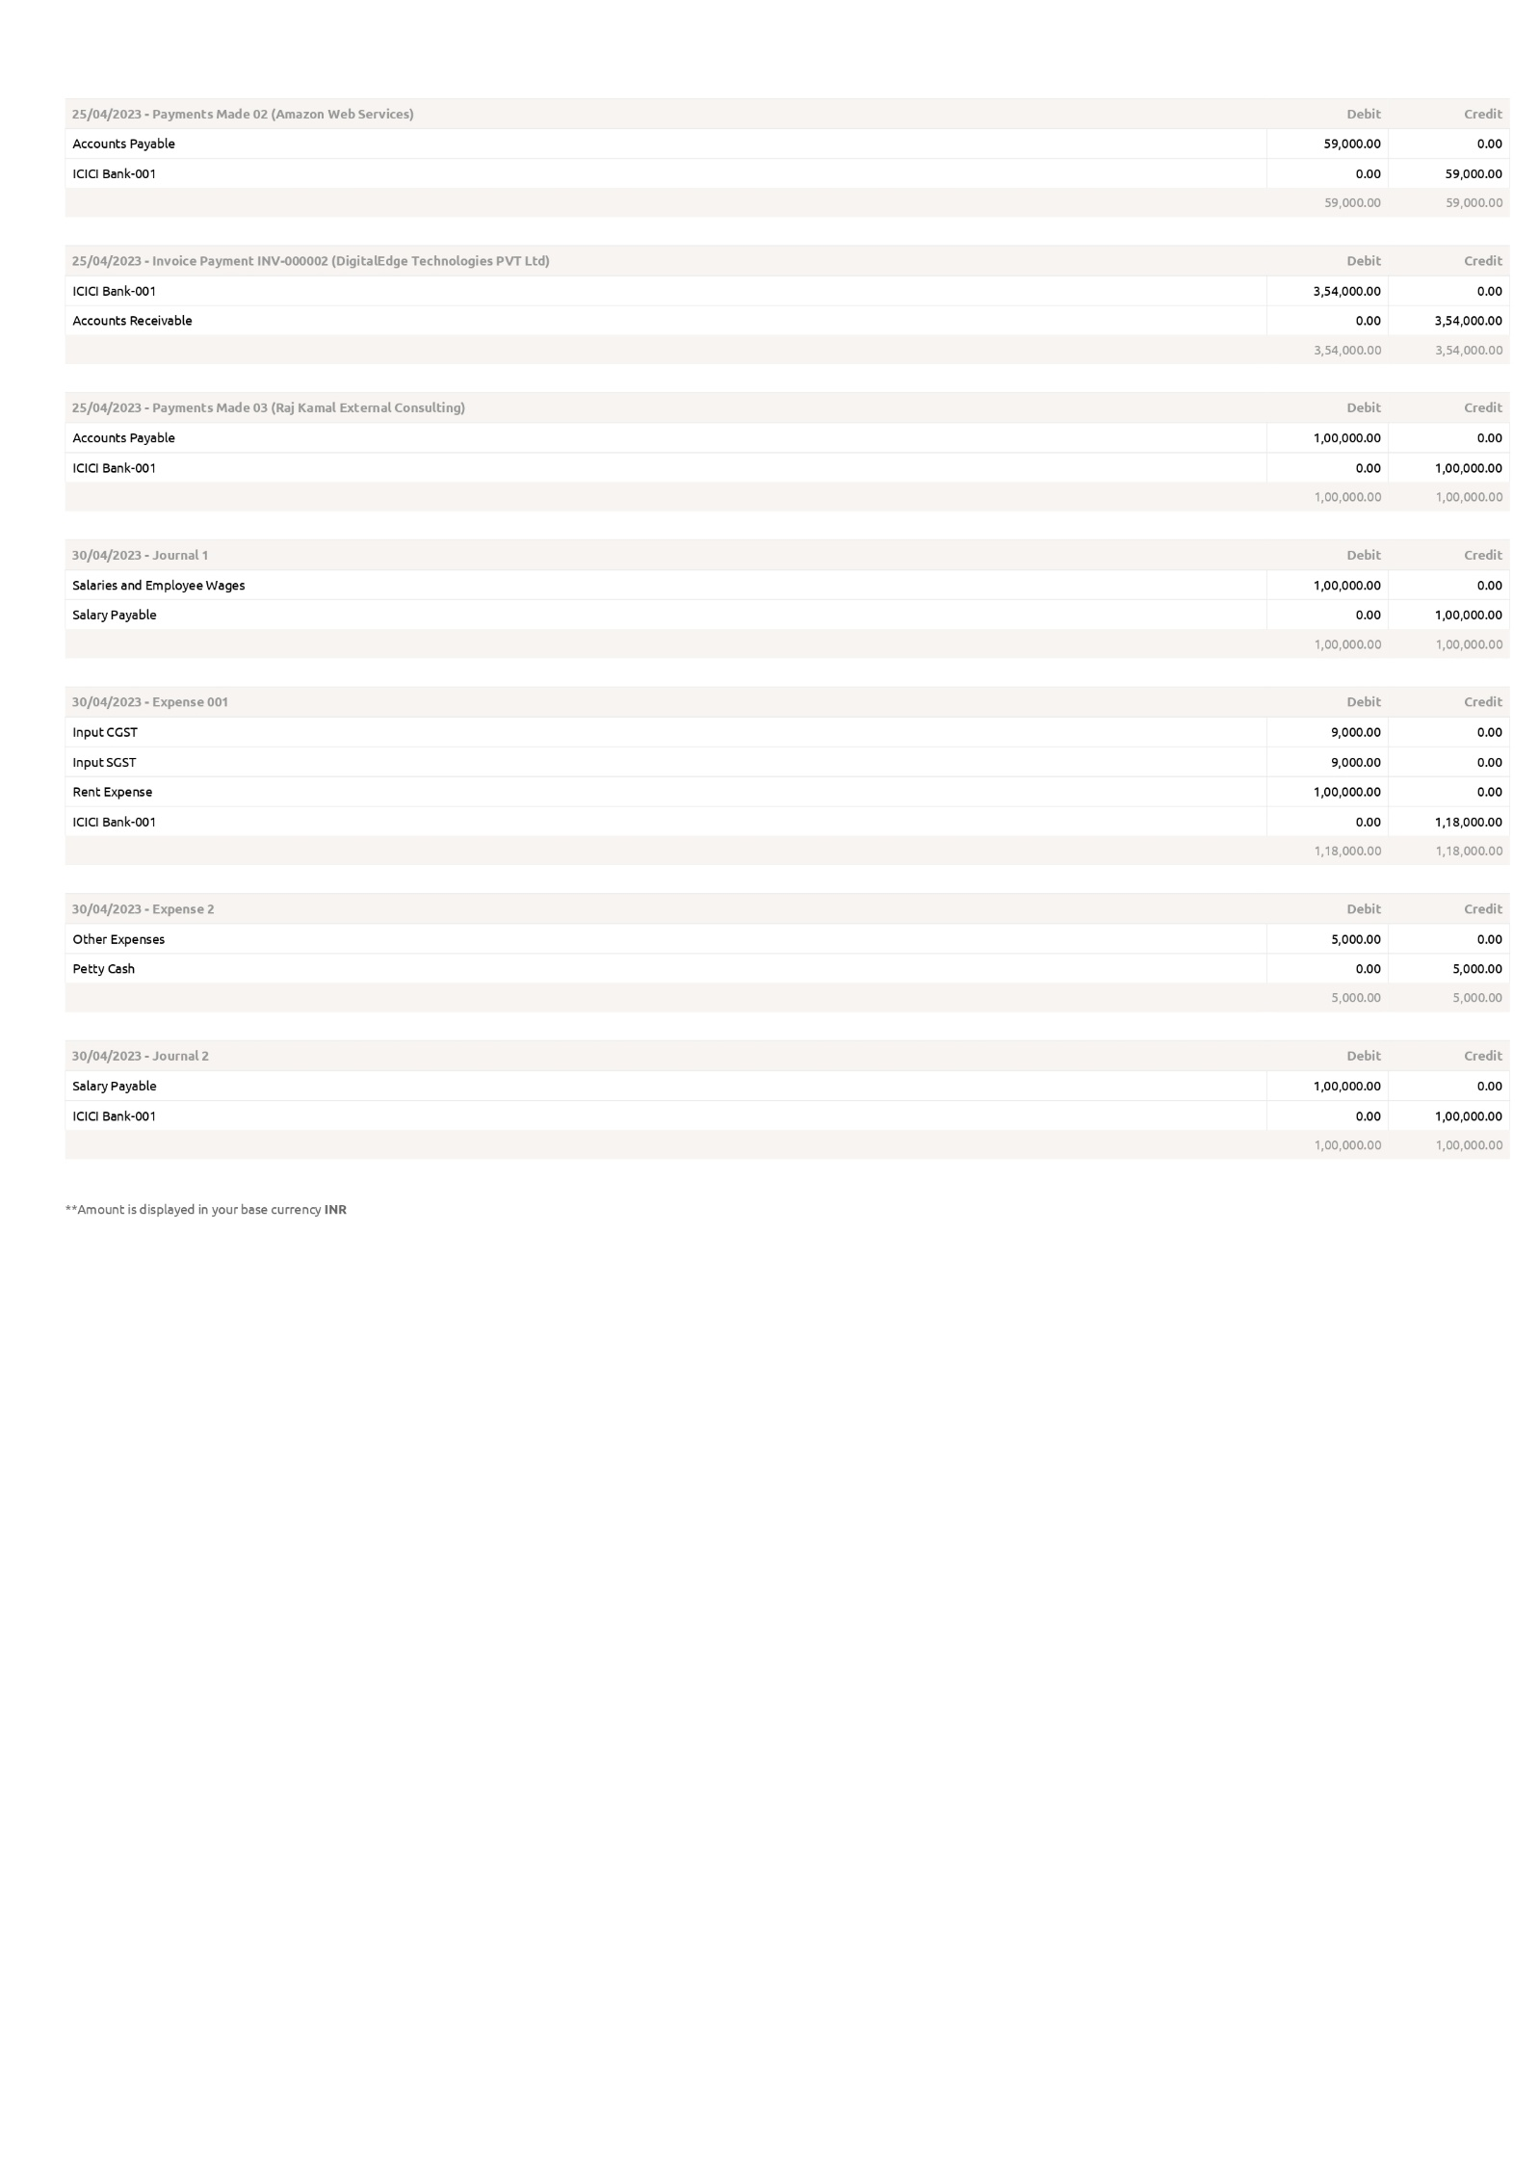

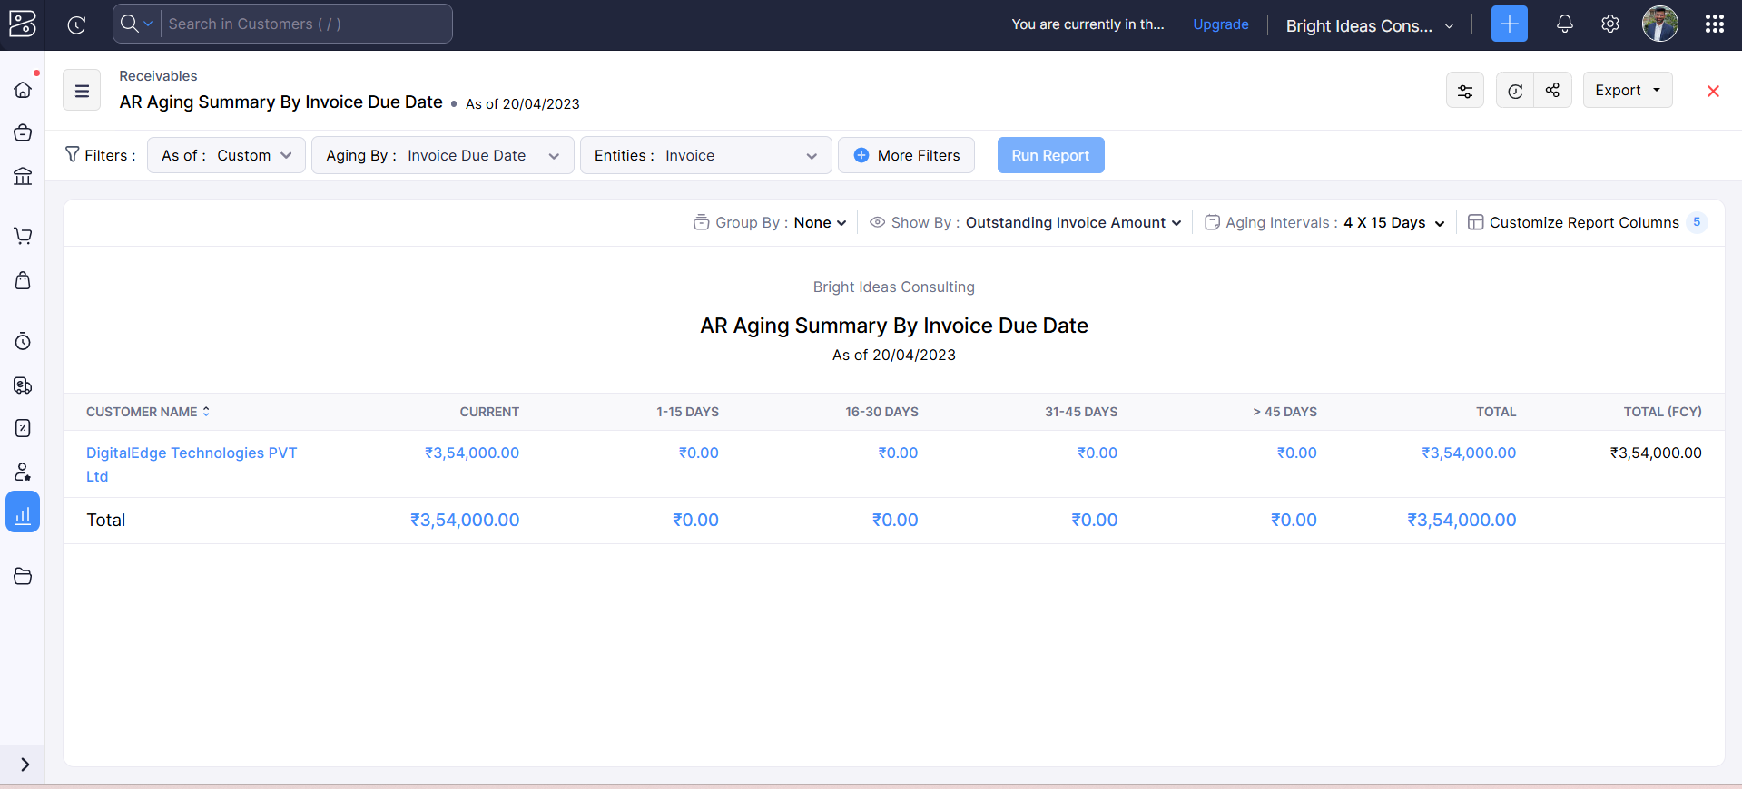**Activity 5: Accounts Receivable Aging Details**

**Activity 6: Accounts Payable Aging Details**

